



INTERNSHIP REPORT



**An Internship Report**

**On**

**Unveiling Trends: Holistic Retail Management and Customer Data Analysis**

**by**

E.Pranith Kumar– 21951A67AA6

Haasini Ragam – 21951A0556

V.Gowtham– 21951A12D0



**INSTITUTE OF AERONAUTICAL ENGINEERING**

**(Autonomous)**

**Dundigal, Hyderabad – 500 043, Telangana**

**May, 2024**

### **DECLARATION**

### 

I certify that

1. The work contained in this report is original and has been done by me under the guidance of my supervisor.
2. The work has not been submitted to any other Institute for any degree or diploma.
3. I have followed the guidelines provided by the Institute for preparing the report.
4. I have conformed to the norms and guidelines given in the Code of Conduct of the Institute.
5. Whenever I have used materials (data, theoretical analysis, figures, and text) from other      sources, I have given due credit to them by citing them in the text of the report and giving their details in the references. Further, I have taken permission from the copyright owners of the sources, whenever necessary.

#### Place: Hyderabad                                                                                     Signature of the Student

**Date:                                                                                            Roll No. 21951A67A6**

**Acknowledgement**

I extend my heartfelt gratitude to **Makri Solutions (OPC) Private Limited, Hyderabad** - 500038, for providing me with the opportunity to undertake this internship project. I am deeply thankful to **Dr. D V Ramana**, Project Manager, for his invaluable guidance, mentorship, and unwavering support throughout the internship. His expertise and insights have been instrumental in shaping my understanding and skills in [mention specific area, e.g., "Human Resource Analytics"]. I am also grateful to the entire team at Makri Solutions for their encouragement and assistance, which significantly contributed to the success of this project. This internship experience has been invaluable in my professional development, and I am privileged to have been part of Makri Solutions (OPC) Private Limited during this transformative journey.

**With sincere regards,**

E.Pranith Kumar 21951A67A6

Haasini Ragam 21951A0556

V.Gowtham 21951A12D0

**Abstract**

Holistic retail management and customer data analysis are crucial for modern retailers aiming to enhance efficiency, satisfaction, and profitability. By integrating supply chain coordination, inventory control, and customer service, businesses ensure seamless operations and a consistent customer experience. This study, analysing 25,000 transactions, reveals that personalized marketing, driven by customer data insights, boosts engagement and conversion rates. Inventory optimization benefits from demand forecasting, while customer service and product development improve through behavioral insights. Python aids in data processing, and Power BI enhances data visualization. This integrated approach helps retailers optimize operations, personalize experiences, and drive sustainable growth.

Keywords: Holistic Retail Management, Customer Data Analysis, Supply Chain Coordination

Inventory Control.

**TABLE OF CONTENTS**

**Title**

**Abstract**

**Acknowledgment**

**About the Authors**

Chapter 1 – Introduction

* 1. Background .………………………………………………………………......... 3
  2. Storytelling ..………………………………………………………………........ 4
  3. Get Started .…………………………………………………………………......10

1.4 Libraries .………………………………………………………………….........14

Chapter 2 – Project Process Flow

2.1Data Preparation and Data Preprocessing …………………………….………..15

2.1.1 Data Acquisition

2.2.2 Data Preprocessing

Chapter 3 – Data Analysis ......…………………………………………………....................22

Chapter 4 – Data Visualization ...............................................................................................27

Chapter 5 – Challenges ….......................................................................................................43

Chapter 6 – Glossaries ............................................................................................................44

Chapter 7 – Conclusion ..........................................................................................................45

Chapter 8 – Reference ............................................................................................................46

**Chapter 1**

**Introduction**

Retailers today face the challenge of optimizing operations, ensuring consistent customer experiences, and driving profitability. Leveraging holistic retail management and customer data analysis, supported by technologies like Python and Power BI, enables businesses to make informed decisions, personalize interactions, and stay competitive in a dynamic market.

**1.1 Background**

**Overview of Data Analytics and Visualization:**

Data Analytics involves examining datasets to draw conclusions about the information they contain, using specialized systems and software. It encompasses various techniques from simple statistical analysis to complex data mining and predictive analytics.

**What is Data Visualization?**

Data Visualization refers to the graphical representation of information and data. By using visual elements like charts, graphs, and maps, data visualization tools provide an accessible way to see and understand trends, outliers, and patterns in data.

**Importance of Data Analytics and Visualization**

1.Enhanced Decision Making: Helps in making informed decisions by providing insights derived from data.

2.Identifying Trends and Patterns: Facilitates the recognition of trends, patterns, and anomalies that might not be apparent in raw data.

3.Increased Efficiency: Streamlines the decision-making process and helps in solving problems quickly.

4.Improved Communication: Makes it easier to communicate complex data insights to stakeholders through visual representation.

5.Data-Driven Strategies: Enables the development of strategies based on data-driven insights, leading to better outcomes.

6.Performance Tracking: Assists in monitoring and evaluating performance across different areas of business or operations.

**Advantages of Data Visualization**

* Simplifies Complex Data: Makes large and complex data sets comprehensible by presenting them visually.
* Quick Insights: Allows for quick and accurate interpretation of data.
* Interactive Exploration: Tools often allow interactive exploration of data, helping users to uncover hidden insights.
* Enhanced Data Storytelling: Enables effective storytelling through visual means, making data more engaging.

**Disadvantages of Data Visualization**

* Misleading Information: Poor design choices can lead to misinterpretation or distortion of data.
* Oversimplification: Important details might be lost in the process of simplifying data for visualization.
* Data Quality Dependency: The accuracy of visualizations depends heavily on the quality of the underlying data.

Importance of Power BI and Python in Data Analysis

**Power BI** is a powerful business analytics tool by Microsoft that offers a comprehensive solution for data visualization and business intelligence. It enables users to transform raw data into actionable insights through its easy-to-use interface and robust capabilities.

Key Benefits of Power BI in Data Analysis:

1. **User-Friendly Interface**:

* Power BI’s drag-and-drop functionality makes it accessible to users with varying levels of technical expertise.
* The intuitive design allows users to quickly create and customize visual reports and dashboards.

1. **Integration with Multiple Data Sources:**

* Power BI supports a wide range of data sources including Excel, SQL Server, Azure, and cloud services like Salesforce and Google Analytics.
* The ability to connect to various data sources enables comprehensive data analysis from disparate systems.

1. **Real-Time Data Processing:**

* Power BI can handle real-time data, providing up-to-date insights and allowing for timely decision-making.
* Integration with streaming data sources facilitates real-time monitoring and alerting.

1. **Interactive Visualizations:**

* Power BI offers a variety of interactive visualizations, such as bar charts, line charts, scatter plots, and maps.
* Users can drill down into data, apply filters, and interact with visual elements to explore data in-depth.

1. **Collaboration and Sharing:**

* Reports and dashboards can be easily shared within an organization through the Power BI Service.
* Features like workspaces and shared datasets promote collaboration among teams.

1. **Customization and Extensibility:**

* Power BI supports custom visuals and third-party add-ons from the Power BI marketplace.
* Users can extend functionality by embedding Python and R scripts for advanced data manipulation and visualization.

1. **Security and Compliance:**

* Power BI provides robust security features, including row-level security to control access to data.
* Compliance with industry standards and regulations ensures data protection and governance.

**Python** is a versatile programming language widely used for data analysis and visualization due to its powerful libraries and ease of use. It enables advanced data manipulation and the creation of custom, complex visualizations.

**Key Benefits of Python in Data Analysis:**

1. **Extensive Libraries for Data Analysis:**

* Python offers a rich ecosystem of libraries such as Pandas for data manipulation, NumPy for numerical operations, and SciPy for scientific computing.
* These libraries simplify the process of data cleaning, transformation, and analysis.

1. **Advanced Data Visualization:**

* Libraries like Matplotlib, Seaborn, and Plotly allow for the creation of detailed and interactive visualizations.
* Customization options in these libraries enable users to tailor visualizations to specific requirements.

1. **Automation and Efficiency:**

* Python scripts can automate repetitive data processing tasks, improving efficiency and accuracy.
* This automation capability is crucial for handling large datasets and complex workflows.

1. **Machine Learning and AI Integration:**

* Python’s machine learning libraries, such as Scikit-learn, TensorFlow, and PyTorch, enable the development of predictive models and AI applications.
* Integration of these models into data analysis workflows provides deeper insights and forecasts.

1. **Flexibility and Scalability:**

* Python’s flexibility allows for the analysis of data from diverse sources and formats.
* The language can scale to handle large volumes of data, making it suitable for both small and large datasets.

1. **Community Support and Resources:**

* Python has a large and active community, providing extensive documentation, tutorials, and support.
* Continuous development and updates ensure that Python remains a cutting-edge tool for data analysis.

**Combining Power BI and Python**

**Enhanced Data Visualization**:

* While Power BI provides robust data visualization capabilities, Python can be used to create custom visuals and perform advanced data manipulation before importing the results into Power BI.

**Advanced Analytics and Machine Learning:**

* Python’s powerful libraries for statistical analysis and machine learning can be leveraged to perform complex analyses, with the results integrated into Power BI dashboards for visualization and reporting.

**Automation of Data Workflows:**

* Python scripts can automate data extraction, transformation, and loading (ETL) processes, which can then feed into Power BI for visualization and analysis.

**Extending Power BI Functionality:**

* Python can be used within Power BI to extend its capabilities, such as by using Python scripts in Power BI Desktop for advanced data manipulations that are not possible with DAX or Power Query alone.

**Compare Power BI Visualization and Python Visualization Power BI Visualization**

**Strengths:**

1. **Ease of Use:**

* User-friendly interface with drag-and-drop functionality.
* No coding required, making it accessible to non-technical users.

1. **Integration with Data Sources:**

* Seamless integration with numerous data sources like Excel, SQL Server, Azure, and cloud services.
* Real-time data connectivity.

1. **Interactive Dashboards:**

* Highly interactive dashboards with built-in features like filters, slicers, and drill-through capabilities.

1. **Collaboration and Sharing:**

* Easy sharing and collaboration through the Power BI Service.
* Role-based access control for secure sharing.

1. **Pre-built Visualizations:**

* Extensive library of pre-built visualizations such as bar charts, pie charts, line charts, maps, etc.
* Custom visuals available from the Power BI marketplace.

1. **Continuous Updates:**

* Regular updates and new features from Microsoft.

1. **Integration with Other Microsoft Tools:**

* Deep integration with other Microsoft products like Excel, Teams, and SharePoint.

**Weaknesses:**

1. **Customization Limitations:**

* Limited customization compared to programming languages.
* Some complex visualizations may not be achievable with default options.

1. **Cost:**

* While there is a free tier, advanced features and sharing capabilities require a paid subscription.

1. **Performance with Large Datasets:**

* Can experience performance issues with very large datasets or complex models.

**Use Cases:**

* Business reporting and dashboarding.
* Quick insights and ad-hoc analysis.
* Collaboration and sharing insights across teams.

**Python Visualization Strengths:**

1. **Flexibility and Customization:**

* Highly customizable visualizations tailored to specific needs.
* Ability to create complex and unique visualizations using libraries like Matplotlib, Seaborn, Plotly, and Bokeh.

1. **Advanced Analytics:**

* Integration with powerful data analysis and machine learning libraries like Pandas, NumPy, Scikit-learn, TensorFlow.

1. **Scalability:**

* Capable of handling large datasets and complex data transformations.
* Automation of data processing workflows**.**

1. **Open Source:**

* Free and open-source libraries with extensive community support.

1. **Reproducibility:**

* Scripts can be easily shared and reproduced by other users.

**Integration with Other Tools:**

* ○Can be used in conjunction with other data processing and storage tools, such as SQL databases and cloud storage.

**Weaknesses:**

1. **Learning Curve:**

* Requires knowledge of programming and familiarity with Python.
* Steeper learning curve for users without a coding background.

1. **Less Interactive:**

* By default, visualizations are static, though interactivity can be added with libraries like Plotly and Bokeh.

1. **Manual Process:**

* More manual effort required to set up and create visualizations compared to Power BI’s drag-and-drop interface.

**Use Cases:**

* Detailed and customized data analysis and visualization.
* Research and exploratory data analysis.
* Complex data transformations and automation.
* Integration with machine learning workflows.

**1.2 Getting Started:**

* **Installing Jupyter Notebook and Necessary Libraries**

1. Install Python:

Before installing Jupyter, you need to have Python installed on your system. You can download the latest version of Python from the official [Python website](https://www.python.org/downloads/). Follow the installation instructions for your operating system. Make sure to check the box that says "Add Python to PATH" during installation.

To verify that Python is installed, open your terminal (or command prompt) and run:

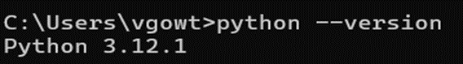

This should display the installed Python version. If it doesn’t, you might need to add Python to your system PATH.

1. Install pip:

pip is the package installer for Python. It should be installed by default with Python. You can check if pip is installed by running the following command in your terminal or command prompt:



If pip is not installed, you can install it by following the instructions [here](https://pip.pypa.io/en/stable/installation/).

1. Install Jupyter Notebook:

Open a terminal or command prompt. Install Jupyter Notebook using pip.



1. Create a New Jupyter Notebook:

Launch Jupyter Notebook from the terminal or command prompt by typing Jupyter Notebook.



Create a new Python notebook from the Jupyter interface.

1. Install Essential Libraries:

Open a new code cell in your Jupyter Notebook. Use pip to install the following libraries:

* pandas-2.2.2 # Data manipulation.
* numpy-1.26.4 # Numerical computing.
* seaborn-0.13.2 # Statistical visualization.
* matplotlib-3.7.2 # Plotting framework.
* geopandas-0.14.4 # Spatial data operations.
* scikit-learn-1.4.2 # Machine learning.
* palettable-3.3.3 # Colour palettes.
* plotly-5.22.0 # Interactive visualizations.
* Powerbi-2.130.754.0 #Intractive visualizations

1. Import Libraries

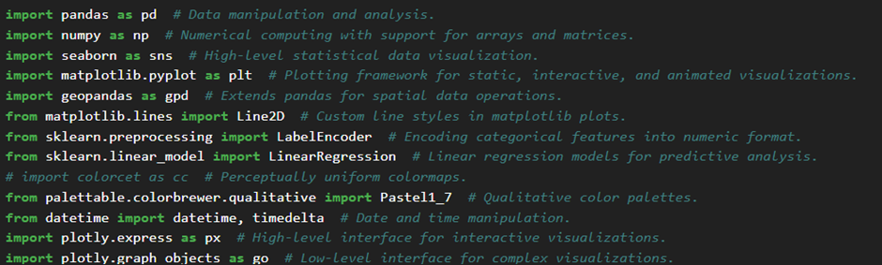

1. Load and Explore Data

* **Setting Up Power BI Desktop**

**Download Power BI Desktop**

Visit the Power BI Website:

* Go to the official Power BI website: [Power BI Desktop Download](https://powerbi.microsoft.com/desktop/).

Download:

* Click on the “Download Free” button.
* You will be redirected to the Microsoft Store or a direct download link will be provided.
* Download the installer file.

**Install Power BI Desktop**

Run the Installer:

* Locate the downloaded installer file (usually in your Downloads folder).
* Double-click the installer file to run it.

Installation Process:

* Follow the on-screen instructions.
* Accept the license agreement and select the installation location if prompted.
* Click on “Install” and wait for the installation to complete.

Complete Installation:

* Once the installation is complete, click on “Finish” or “Launch” to open Power BI Desktop.

**Initial Setup and Configuration**

Open Power BI Desktop:

* If Power BI Desktop doesn’t open automatically, find it in your Start Menu or Desktop and open it.

Sign In:

* If prompted, sign in with your Microsoft account. If you don’t have one, you may need to create an account.

Optional: Update Settings:

* You can customize your settings by clicking on the gear icon (⚙) in the top right corner.
* Adjust regional settings, data load options, and privacy settings as needed.

**Connecting to Data**

Get Data:

* Click on the “Get Data” button on the Home ribbon.
* Select the data source you want to connect to (e.g., Excel, SQL Server, Web, etc.).

Load Data:

* Follow the prompts to connect to your data source.
* Preview the data and click “Load” to import it into Power BI Desktop.

**Building Queries and Data Models:**

* Use the Power Query Editor to clean and transform your data. You can remove duplicates, handle missing values, and perform other data transformation tasks.
* Create relationships between different data tables by dragging and dropping fields in the Relationships view.
* Use DAX to create calculated columns and measures for advanced calculations.

**Start Creating Reports**

Begin with Visualizations:

* Use the visualization pane on the right to drag and drop fields into the report canvas.
* Customize your visualizations with various options available.

Save Your Work

**1.3 Libraries Used**

* python 3.12.1
* sacremoses 0.1.1
* scikit-learn 1.4.2
* scipy 1.12.0
* seaborn 0.13.2
* numpy 1.26.4
* geopandas 0.14.4
* plotly 5.22.0
* pandas 2.2.2
* pip 23.3.2
* palettable 3.3.3
* power Bi 2.129.1229.

**Chapter 2**

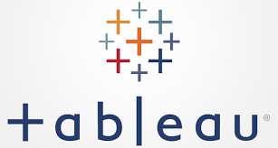Project Process Flow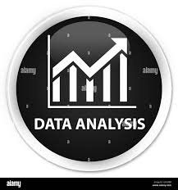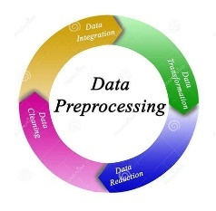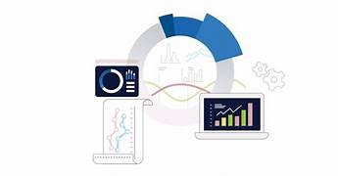

**WORK**

**FUTURE**

**DATA COLLECTION**

**DATA SET**

**DATA PREPROCESSING**

**DATA UNDERSTANDING**

**2.1 Data Preparation and Data Preprocessing:**

**2.1.1 Data Acquisition:**

**Source of the Data**

The dataset used in this project was obtained from the GitHub repository. The specific file used is an Excel (.xl) file that contains relevant data for the analysis.

**Accessing the Data**

To access the dataset, follow these steps:

1. Navigate to the GitHub repository URL: [https://www.kaggle.com/datasets/praneethkumar007/dmart-ready-online-store].
2. Locate the Excel file within the repository. The file is named [final test1.xlsx].
3. Download the file to your local machine by clicking the "Download" button or using GitHub's raw file view to save the file.

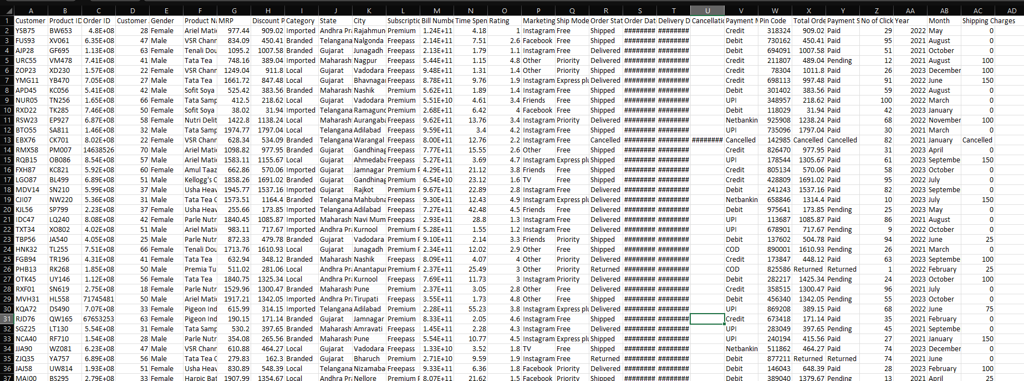

**2.2 Data Preprocessing & Cleaning:**

**Data Preprocessing:**

* pandas (pd): Handles data frames, like spreadsheets, for analysis and manipulation.
* numpy (np): Provides powerful tools for working with numbers in arrays and matrices.
* seaborn (sns): Creates informative and visually appealing statistical charts.
* matplotlib.pyplot (plt): Makes various plots, from basic to complex and interactive.
* geopandas (gpd): Adds geographic data handling capabilities to pandas.
* LabelEncoder: Converts text labels (like categories) into numerical values.
* LinearRegression: Creates models to predict values based on relationships between features.
* datetime: Works with dates and times for data processing.
* plotly.express (px): Builds interactive charts for exploration.
* plotly.graph_objects (go): Offers more control for creating complex visualizations.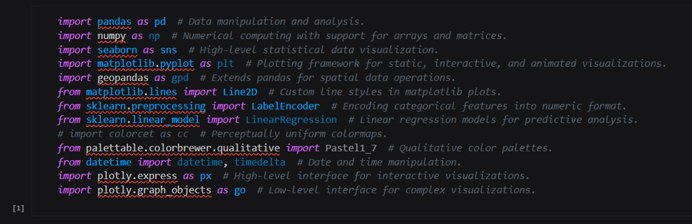
* Import: pd.read_csv function from the pandas library is used to read data from a CSV file.
* File path: The file path is specified as r'D:\project\New folder\final test1.csv'.
* Data frame creation: The loaded data is converted into a pandas dataframe, a tabular data structure, and assigned to the variable data.
* Data Exploration: data.head() method displays the first few rows of the dataframe, providing a glimpse into the data's contents.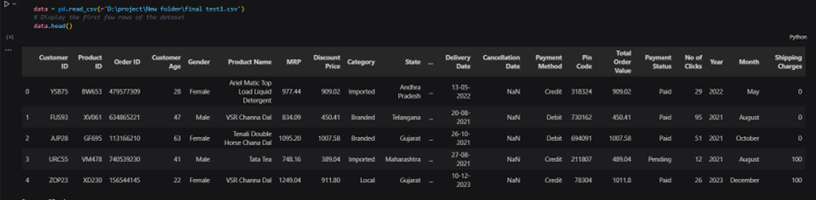
* print(data.shape): This line prints the shape of the data, which is the number of rows and columns in the dataframe. It helps understand the size of the data you're working with.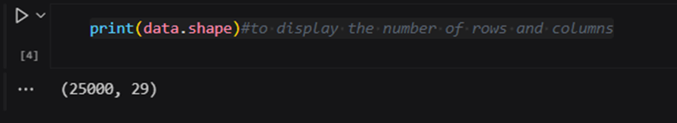
* data.tail(): This line displays the last few rows of the dataframe by default (typically 5 rows). This gives you a glimpse of what the data looks like towards the end.

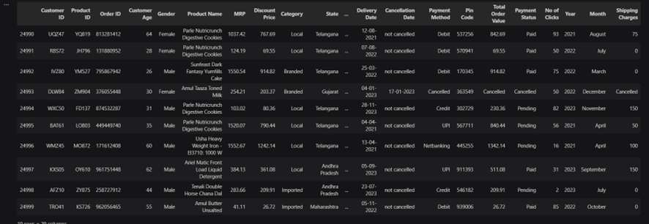

* data.sample(5): This line displays a random sample of 5 rows from the dataframe. This helps get a general idea of the data's content without looking at all rows.

**Data Cleaning:**

* Checks for missing values: data.isnull().sum() counts missing values in each column of the pandas dataframe data.
* Fills missing cancellation dates: It replaces missing values in the 'Cancellation Date' column with the text 'not cancelled' using data['Cancellation Date'] = data['Cancellation Date'].fillna('not cancelled').
* Shows last 10 rows: data.tail(10) displays the last 10 rows of the dataframe after the cleaning operations.
* # Check for missing values
* data.isnull().sum() # Basic statistics
* data.describe() # Display cleaned data
* data.info()
* Check for missing values: data.isnull().sum() counts missing values in each column of the data frame data.
* Basic statistics: data.describe() generates summary statistics of the data, like mean, standard deviation, quartiles, etc., for numerical columns.
* 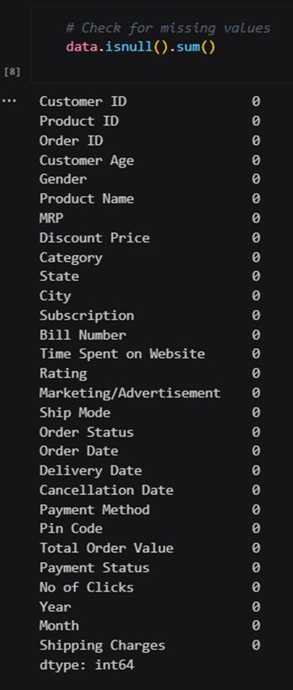Display data info: data.info() provides information about the data, including data types and non-null value counts for each column.

**Handling Missing Numerical Values:**

* The code attempts to convert the 'Total Order Value' column into numerical format using pd.to_numeric.
* The errors='coerce' argument instructs the function to replace any conversion errors (likely due to non-numeric values) with NaN (Not a Number).

**Removing Rows with Missing Values:**

* The dataframe is then filtered using df.dropna(subset=['Total Order Value']).
* This keeps only rows where the 'Total Order Value' column has valid numerical data (not NaN).

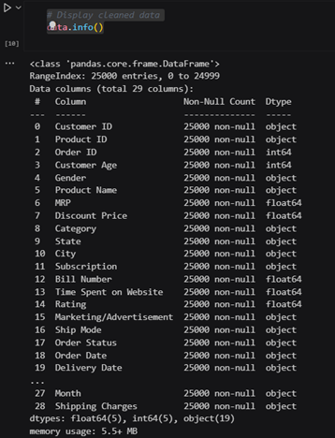

In simpler terms, this code cleans a data column by converting text values (if any) to numbers and then removes rows with missing numbers. This prepares the data for numerical analysis.

The dataset includes 28 columns, providing a comprehensive range of data points for analysis. Each column represents a different variable or attribute, contributing to a detailed and multifaceted dataset. This diversity of data enhances the potential for in-depth insights and thorough examination across multiple dimensions of the dataset.

1. **Customer ID:** Unique identifier for each customer.
2. **Product ID:** Unique identifier for each product.
3. **Order ID:** Unique identifier for each order.
4. **Customer Age:** Age of the customer.
5. **Gender:** Gender of the customer.
6. **Product Name:** Name of the product.
7. **MRP:** Maximum Retail Price of the product.
8. **Discount Price:** Discounted price of the product.
9. **Category: C**ategory of the product (e.g., Local, Branded).
10. **State:** State from which the order was placed.
11. **City:** City from which the order was placed.
12. **Subscription:** Subscription status of the customer.
13. **Bill Number:** Bill number for the order.
14. **Time Spent on Website:** Time spent by the customer on the website.
15. **Rating:** Rating given by the customer.
16. **Marketing/Advertisement:** Marketing or advertisement details.
17. **Ship Mode:** Shipping mode used for the order.
18. **Order Status:** Current status of the order.
19. **Order Date:** Date on which the order was placed.
20. **Delivery Date:** Date on which the order was delivered.
21. **Cancellation Date:** Date on which the order was cancelled (if applicable).
22. **Payment Method:** Method used for payment.
23. **Pin Code:** Pin code of the delivery address.
24. **Total Order Value:** Total value of the order.
25. **Payment Status:** Status of the payment (e.g., Paid, Pending).
26. **No of Clicks:** Number of clicks made by the customer.
27. **Year:** Year in which the order was placed.
28. **Month:** Month in which the order was placed.

**Chapter 3**

**Data Analysis Techniques**

In this report, we present a comprehensive analysis of the D-Mart ready sales database, focusing on uncovering trends, patterns, and insights that can drive informed decision-making. Our analysis begins with an essential step: data cleaning. The raw sales data is meticulously prepared by addressing missing values, removing duplicates, and correcting inconsistencies. This process ensures the integrity and accuracy of the data, laying a solid foundation for subsequent analysis.

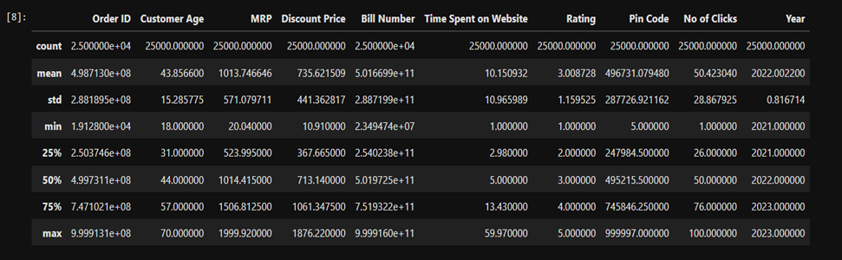

Figure: Statistical Analysis of the dataset

**Customer Lifetime Value (CLV) Analysis**

Customer lifetime value (CLV) analysis is another critical component of our report. This analysis focuses on understanding the long-term value of different customer segments by examining historical purchase data and customer interactions. Estimating the future value each customer brings to the company helps in identifying high-value customers, optimizing retention strategies, and improving targeted marketing efforts.

### **Sentiment Analysis**

Additionally, we conduct sentiment analysis on customer feedback, reviews, and social media interactions to gain insights into customer satisfaction and brand perception. By analyzing sentiments expressed in customer reviews and social media posts, we identify areas for improvement, address customer concerns, and enhance the overall customer experience.

**Descriptive Statistics**

The dataset consists of 25,000 entries with various attributes related to retail transactions. Here are some key descriptive statistics:

1. Customer Age ranges from 18 to 70 years, with a mean age of 44.08.

2. Total Order Value ranges from 10.73 to 1888.26, with a mean value of 730.38.

The dataset includes both numerical and categorical variables, providing a comprehensive view of retail transactions, customer demographics, and product details.

**Numerical Attributes**

For numerical attributes, we calculated the mean, median, standard deviation, minimum, maximum, and quartiles.

**1.Order ID**

* Mean: 498,713,020.8
* Median: 499,731,100
* Standard Deviation: 288,189,479.7
* Min: 19,128
* Max: 999,913,100
* Quartiles:

25%: 250,374,600

75%: 747,102,100

**2.Customer Age**

* Mean: 43.9 years
* Median: 44 years
* Standard Deviation: 15.3 years
* Min: 18 years
* Max: 70 years
* Quartiles:

25%: 31 years

75%: 57 years

**3.MRP (Maximum Retail Price)**

* Mean: ₹1,013.75
* Median: ₹1,014.42
* Standard Deviation: ₹571.08
* Min: ₹20.04
* Max: ₹1,999.92
* Quartiles:

25%: ₹523.99

75%: ₹1,506.81

**4.Discount Price**

* Mean: ₹735.62
* Median: ₹713.14
* Standard Deviation: ₹441.36
* Min: ₹10.91
* Max: ₹1,876.22
* Quartiles:

25%: ₹367.67

75%: ₹1,061.35

**5.Bill Number**

* Mean: 501,669,925,947
* Median: 501,972,475,013
* Standard Deviation: 288,719,913,506
* Min: 23,494,736
* Max: 999,916,008,244
* Quartiles:

25%: 254,023,782,185

75%: 751,932,231,770

**6.Time Spent on Website**

* Mean: 10.15 minutes
* Median: 5 minutes
* Standard Deviation: 10.97 minutes
* Min: 1 minute
* Max: 59.97 minutes
* Quartiles:

25%: 2.98 minutes

75%: 13.43 minutes

**7.Rating**

* Mean: 3.01
* Median: 3
* Standard Deviation: 1.16
* Min: 1
* Max: 5
* Quartiles:

25%:2

75%: 4

**8.Pin Code**

* Mean: 496,731.08
* Median: 495,215.5
* Standard Deviation: 287,726.92
* Min: 5
* Max: 999,997
* Quartiles:

25%: 247,984.5

75%: 745,846.25

**9.No of Clicks**

* Mean: 50.42
* Median: 50
* Standard Deviation: 28.87
* Min: 1
* Max: 100
* Quartiles:

25%: 26

75%: 76

**10.Year**

* Mean: 2022
* Median: 2022
* Standard Deviation: 0.82
* Min: 2021
* Max: 2023
* Quartiles:

25%: 2021

75%: 2023

**Analysis**

* Order ID: The mean Order ID is approximately 498.7 million, with a wide range from 19,128 to 999.9 million, indicating a large number of transactions.
* Customer Age: The average customer age is about 44 years, with ages ranging from 18 to 70 years, showing a broad age distribution among customers.
* MRP: The mean MRP is around ₹1,013.75, with a maximum of ₹1,999.92, reflecting a wide price range for products.
* Discount Price: On average, the discount price is ₹735.62, with discounts ranging from ₹10.91 to ₹1,876.22.
* Bill Number: The average bill number is 501.7 billion, with a wide distribution, indicating a large volume of billing entries.
* Time Spent on Website: Customers spend an average of 10.15 minutes on the website, with some spending up to nearly 60 minutes, suggesting varying engagement levels.
* Rating: The average rating is 3, indicating moderate customer satisfaction.
* Pin Code: The mean pin code is 496,731, showing transactions across a wide range of geographical locations.
* No of Clicks: The average number of clicks is 50.42, with a maximum of 100 clicks, indicating varied interaction levels with the website.
* Year: The data spans from 2021 to 2023, with a mean year of 2022, indicating a three-year analysis period.

**Chapter 4**

**Data Visualisation**

**4.1 Using Python:**

1. **Histogram**

The histogram visualizes the age distribution of D-Mart customers, displaying a relatively uniform spread across ages 20 to 70. Each age group, particularly between 20 and 60, shows a high frequency of around 2,000 to 2,500 customers, indicating a diverse and evenly distributed customer age range. This suggests that D-Mart's customer base is broad and appeals consistently across various age demographics. The consistency in customer age frequency highlights the brand's wide-reaching appeal and the potential for age-targeted marketing strategies to further capitalize on this evenly distributed customer demographic.

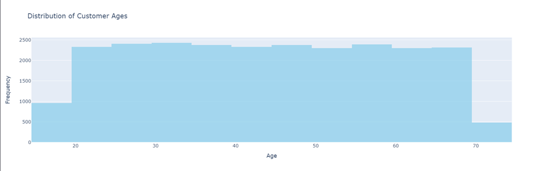

### **Stacked-Bar Graph**

### This Stacked-bar graph represents the distribution of orders, returns, and cancellations by state. The data is grouped by State and Order Status, with the count of each status displayed for each state.

### This Stacked-bar graph shows the counts of orders, returns, and cancellations across four states: Andhra Pradesh, Gujarat, Maharashtra, and Telangana. Each state has a high number of delivered and shipped orders, with Telangana having the highest shipped orders. The cancellation rate is significant in all states, suggesting an area for potential improvement.

1. **Pie Chart**

This pie chart illustrates the gender representation of D-Mart customers, with 57% male and 43% female. The chart uses distinct colours to differentiate between genders: light blue for males and light pink for females. The visual highlights a higher proportion of male customers, indicating a potential focus area for marketing strategies aimed at increasing female customer engagement. This representation provides a clear and concise view of the gender distribution within the customer base.

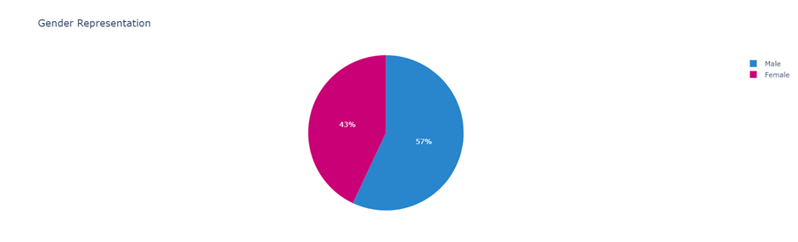

1. **Grouped**-**Line Chart**

This Grouped line chart illustrates the total sales over time for D-Mart across four Indian states: Andhra Pradesh, Gujarat, Maharashtra, and Telangana. The data reveals significant fluctuations in sales across all states, with no consistent upward or downward trend. Notably, Gujarat stands out with the highest peaks, particularly around January 2021 and late 2022, indicating periods of exceptional sales. In contrast, Andhra Pradesh and Maharashtra display more stable sales patterns with moderate variations, suggesting a more consistent sales performance. Telangana shows the highest volatility, with sharp increases and decreases, indicating a more unpredictable sales trend. Overall, the sales trends across all states appear to follow similar seasonal patterns, suggesting the influence of common factors such as holidays, festivals, or economic conditions during specific periods.

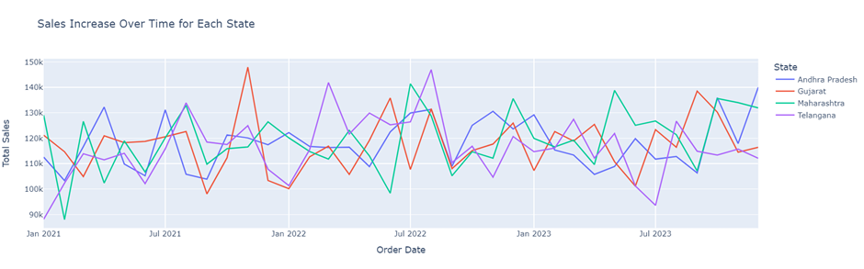

1. **Donut Chart**

The graph is a donut chart, a variation of a pie chart with a hollow center, representing the distribution of preferred shipping modes among customers. It reveals that a majority of customers (56.6%) prefer free shipping, indicating a strong preference for cost-saving options. Priority shipping is the second most popular choice, accounting for 24.9% of the total, suggesting that a significant portion of customers value quicker delivery times. Express plus shipping is chosen by 18.5% of customers, further highlighting the demand for expedited shipping services. Overall, while free shipping dominates, a considerable number of customers are willing to pay extra for faster delivery options.

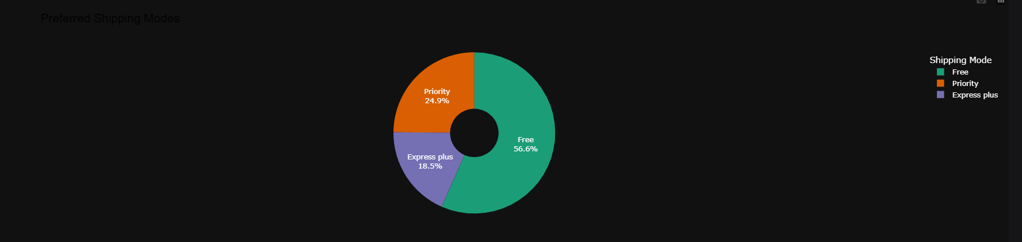

1. **Heat Map**

The heatmap visualizes the distribution of customer ages by gender, using color intensity to represent the number of customers in each age group. It shows that the 30-40 age group has the highest customer count, with females slightly outnumbering males. Most customers are between 20 and 80 years old, with very few in the 0-10 and 90-100 ranges. Females generally have higher counts in most age groups, except for the 10-20 range where both genders have low numbers. The 50-60 and 60-70 age groups have nearly equal distribution between genders.

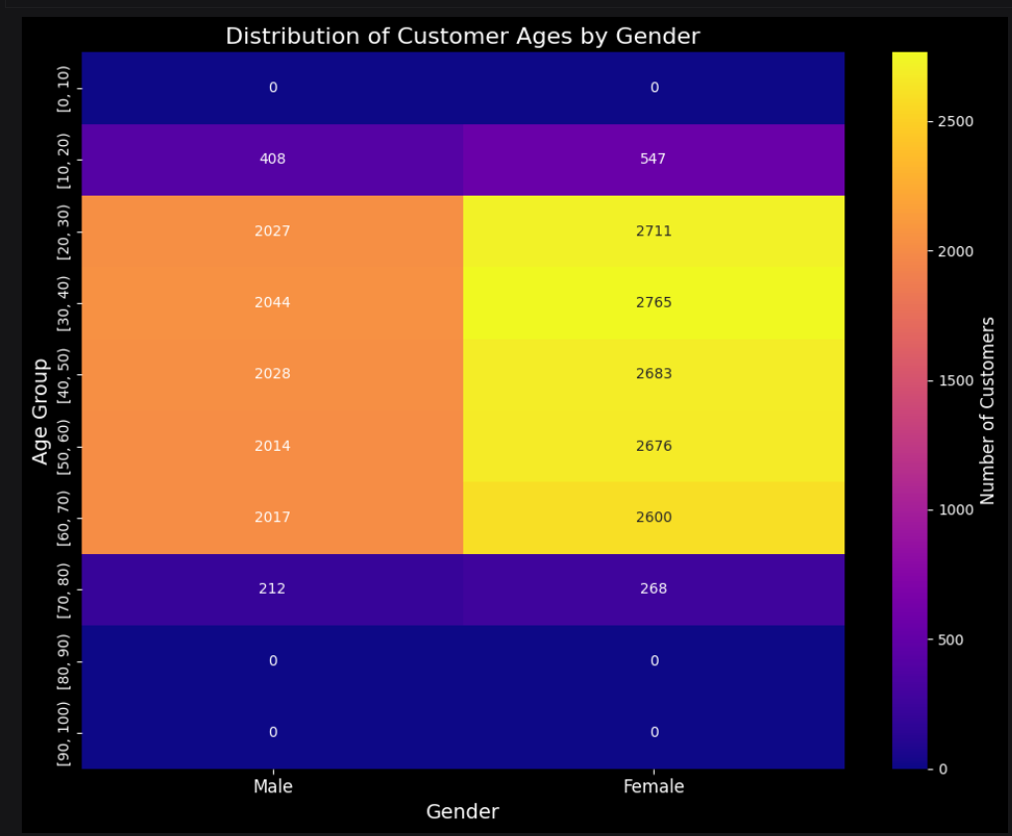

1. **Scatter plot**

The 3D scatter plot visualizes data points in a three-dimensional space, providing a comprehensive view of customer interaction metrics. In this plot, the x-axis represents customer age, offering insight into the age distribution of the customer base. The y-axis indicates the time spent on the website, showing how long customers engage with the site. The z-axis represents the number of clicks, reflecting customer activity and interaction levels. Each data point is colored based on the time spent on the website, creating a color gradient that highlights variations in engagement. This visualization effectively combines age, engagement time, and interaction frequency, allowing for a detailed analysis of customer behavior patterns.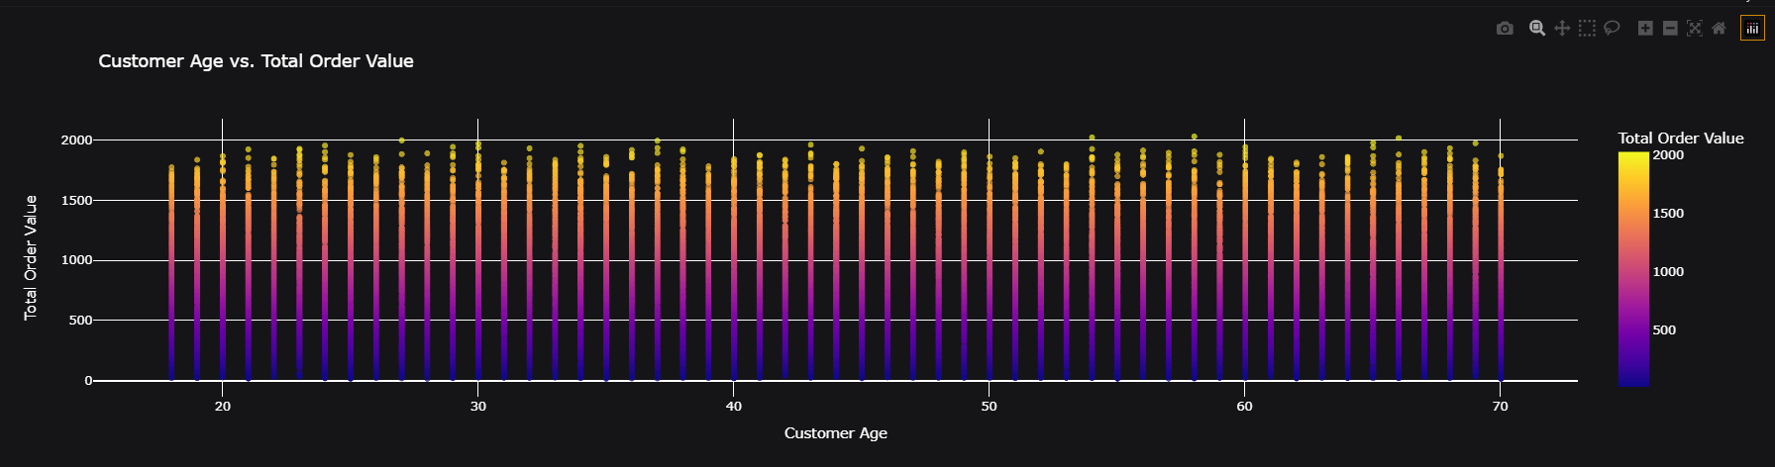

1. **Box Plot**

The box plot displays the distribution of customer age for each marketing/advertisement category. The x-axis represents the customer age, and the y-axis represents the marketing/advertisement categories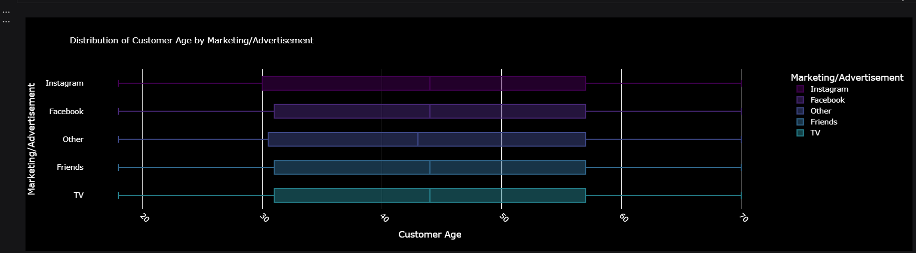

1. **Grouped Bar Plot**

A grouped bar plot illustrates the total order values across different categories, categorized by states. Each category is represented by a set of bars, where each bar shows the total value of orders. States within each category are distinguished by different colours, providing a clear visual comparison of order values across categories and states simultaneously. This visualization helps in identifying patterns of order distribution across various states within each category effectively.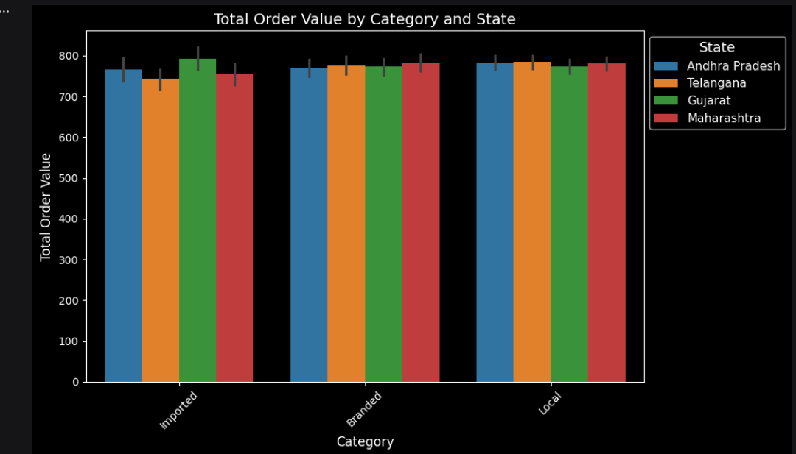

1. **Violin Plot**

A violin plot offers a comprehensive view of the distribution of total order values between genders. For each gender category (Male and Female) on the x-axis, the plot shows the distribution of order values on the y-axis. It combines the statistical summary of a box plot (median, quartiles, outliers) with a density plot, illustrating the probability density of the data at different values. This detailed visualization aids in comparing the spread, skewness, and central tendency of order values across genders, offering insights into the variability and shape of the distribution within each group.

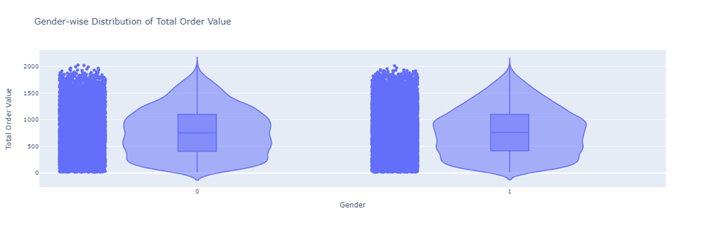

1. **Bar Plot**

The bar plot visually represents the count of cancelled orders categorized by states, offering a straightforward comparison across different regions. Each bar corresponds to a state, with its height indicating the number of cancelled orders. This allows for immediate identification of states with higher cancellation rates, highlighting potential areas for enhancing customer service or optimizing order management processes. Such insights can drive targeted interventions to improve operational efficiency and customer satisfaction, based on specific regional patterns revealed by the visualization.

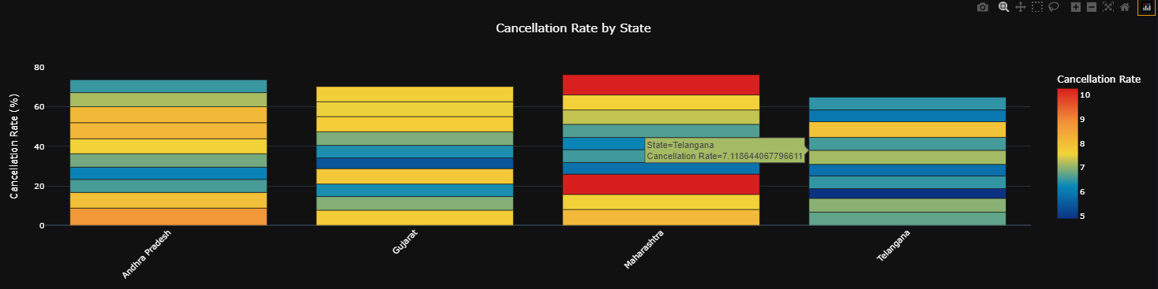

Cancellation by city 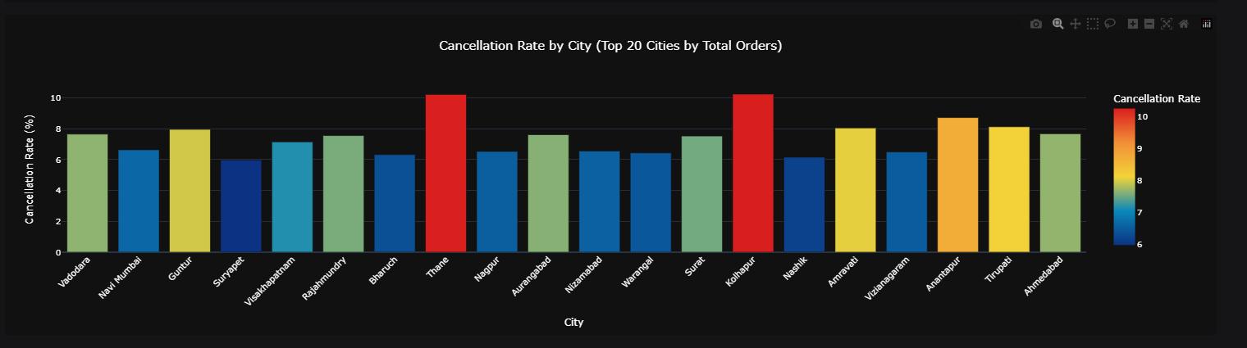

1. **Facet Grid**

The facet grid presents a grid of scatter plots, where each plot examines the relationship between total order value and number of clicks for a distinct combination of gender and category. This structured visualization allows for detailed exploration of how these variables interact within specific demographic and product categories. By segregating the data into individual facets, insights can be gleaned regarding any potential correlations, disparities, or trends unique to each gender-category pair, facilitating targeted analysis and informed decision-making in areas such as marketing strategies or customer segmentation.

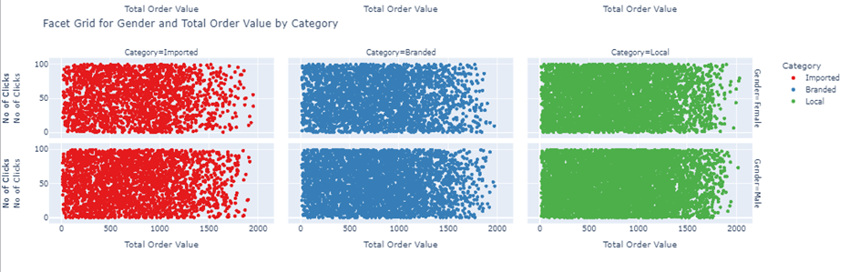

1. **Horizontal Bar Plot**

The horizontal bar plot visualizes the total sales amount attributed to each product, where the x-axis denotes the monetary values and the y-axis lists individual product names. Each bar represents the cumulative sales for a specific product, offering a clear comparison of revenue generation across different items. This visualization is effective for identifying top-selling products as well as outliers in sales performance, enabling strategic decisions related to inventory management, marketing strategies, and product development based on the revenue contributions of each product within the dataset

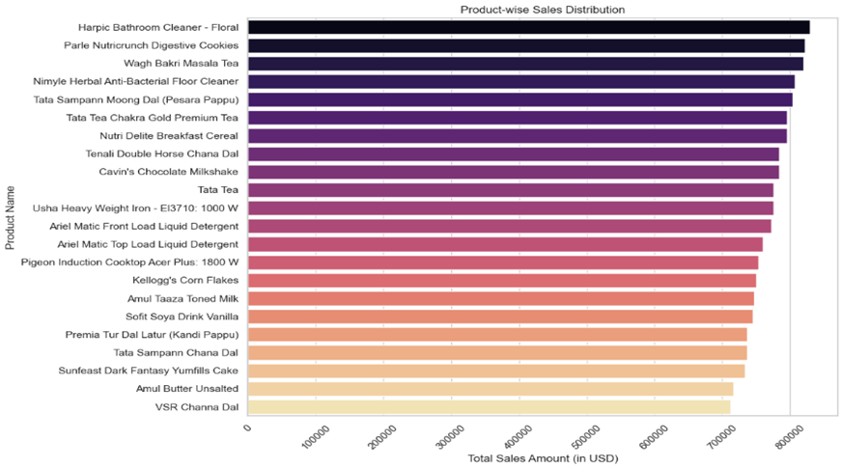.

1. **Line Graph**

The line graph tracks monthly sales trends over time specifically for Andhra Pradesh, providing a detailed depiction of fluctuations and patterns in total sales. Each point on the graph represents sales figures for a specific month, offering a clear visual representation of how sales have evolved over the period analysed. This visualization enables the identification of seasonal variations, growth trends, or periods of decline in sales within Andhra Pradesh, aiding in strategic planning, resource allocation, and decision-making related to sales and market performance in that region.

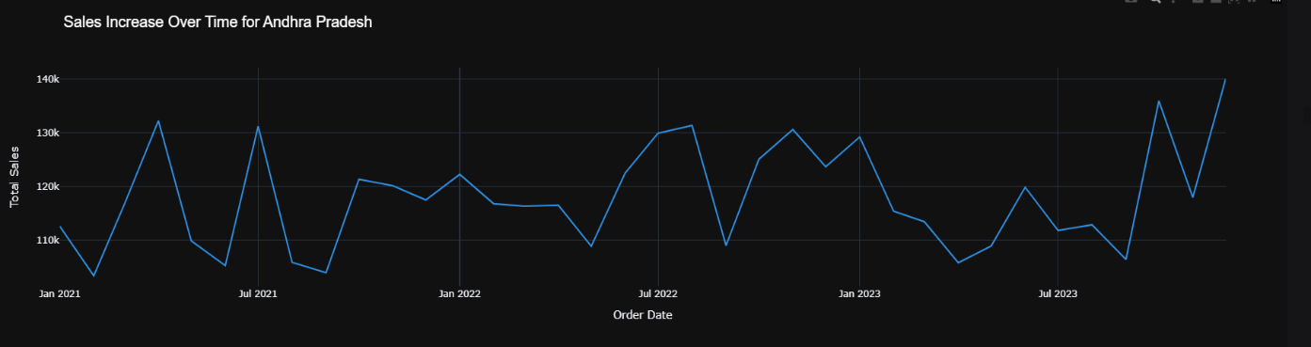

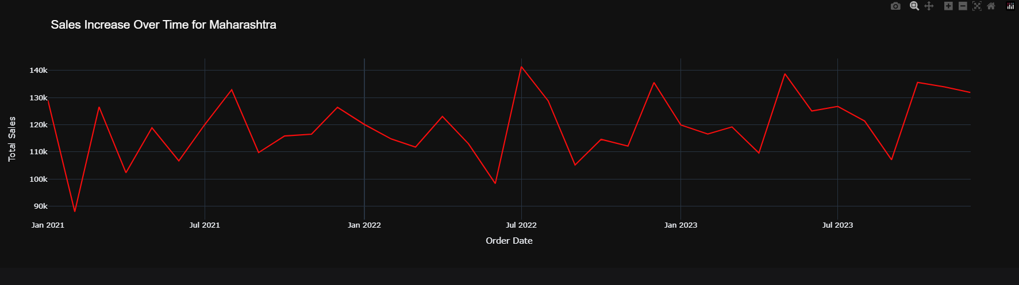

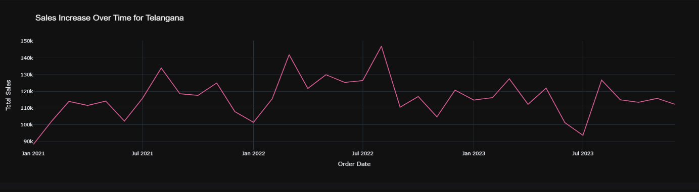

1. **Tree map:**

A tree map visually represents sales data by category and product, illustrating hierarchical relationships. Each rectangle's size corresponds to sales volume, with larger rectangles indicating higher sales. This visualization facilitates the quick identification of top-performing categories and products, supporting strategic decision-making and efficient inventory management in data analysis.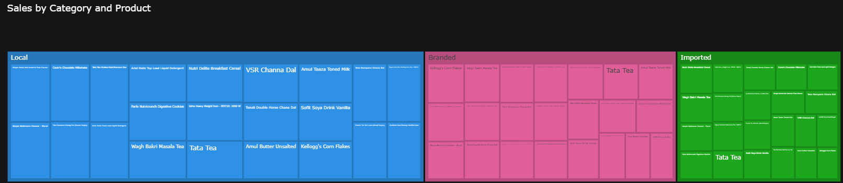

1. **Funnel chart:**

A funnel chart represents the customer journey from awareness to purchase, narrowing as potential customers progress through stages such as discovery, consideration, and decision. A tree map visually illustrates the relation of order processing stages, highlighting the proportion and hierarchy of each stage order placement, processing, shipping, and delivery within the overall process.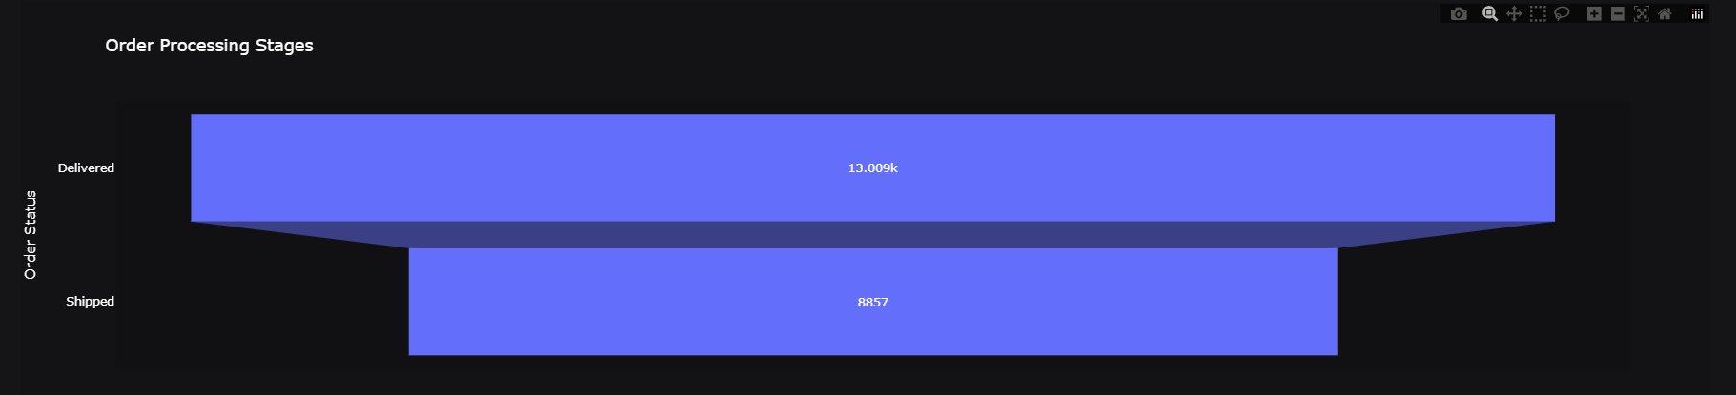

1. **Density Curve:**

A density curve represents the distribution of customer data, such as age, across a continuum. It shows the frequency of customers within different age groups, highlighting patterns and trends. A tree map visualizes the relationship between customer age and other variables, offering insights into age-based purchasing behaviours and demographics.

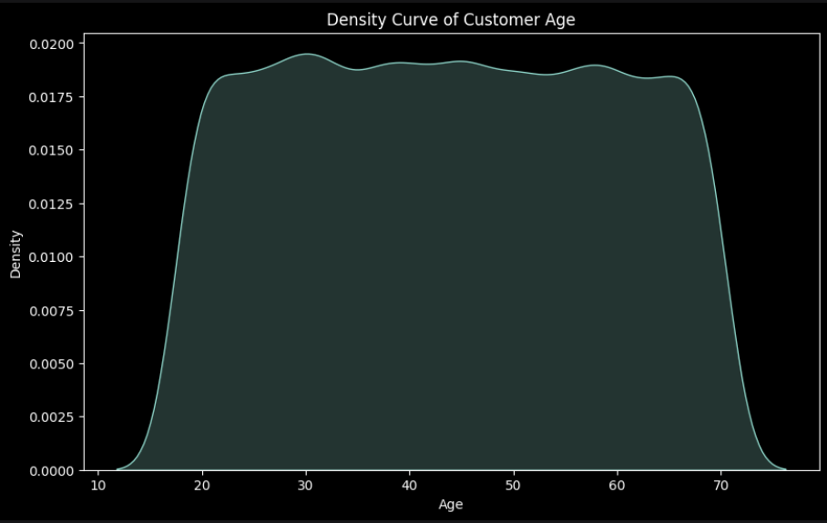

On the other hand, a tree map is a visualization tool that displays the relationship between customer age and other variables in a hierarchical manner. Each rectangle in the tree map represents a category, such as age group, with the size and colour of the rectangles providing additional insights. For instance, a tree map can reveal age-based purchasing behaviours, showing which age groups are more likely to buy certain products. By combining density curves and tree maps, businesses can gain comprehensive insights into customer demographics and purchasing patterns, enabling more effective marketing strategies and product offerings.

1. **Waterfall chart:**

A waterfall chart visually tracks total sales changes across categories, demonstrating cumulative impacts of positive and negative contributions. Python libraries such as Matplotlib and Plotly are utilized to generate these charts, portraying how product categories influence overall sales. This visualization aids in understanding revenue distribution, identifying key contributors, and evaluating trends in sales performance.

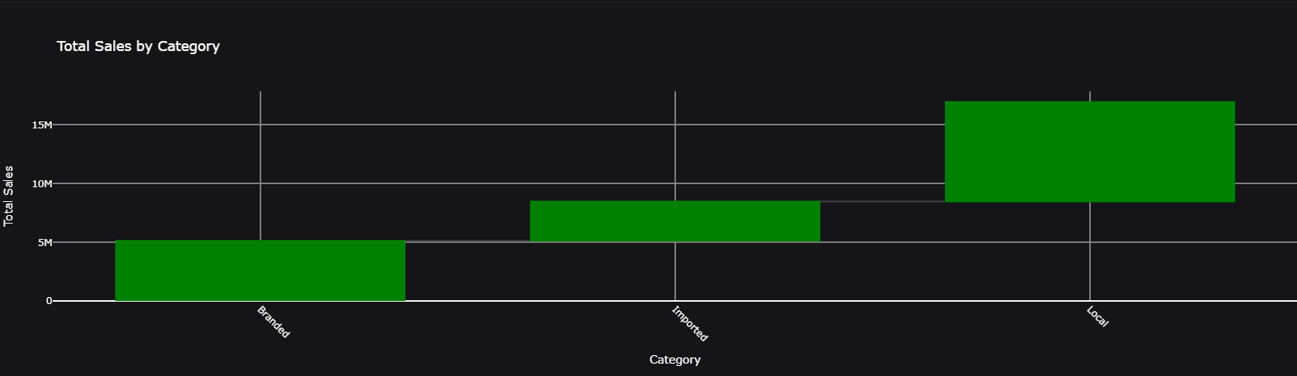

1. **Slope graph:**

A slope graph visually illustrates changes in monthly sales comparisons across categories or products. It effectively showcases trends, highlighting sales increases or decreases over time. When combined with a treemap a visualization depicting sales proportions by area size—it offers a clear, comparative analysis of sales performance among different categories or products across multiple months.

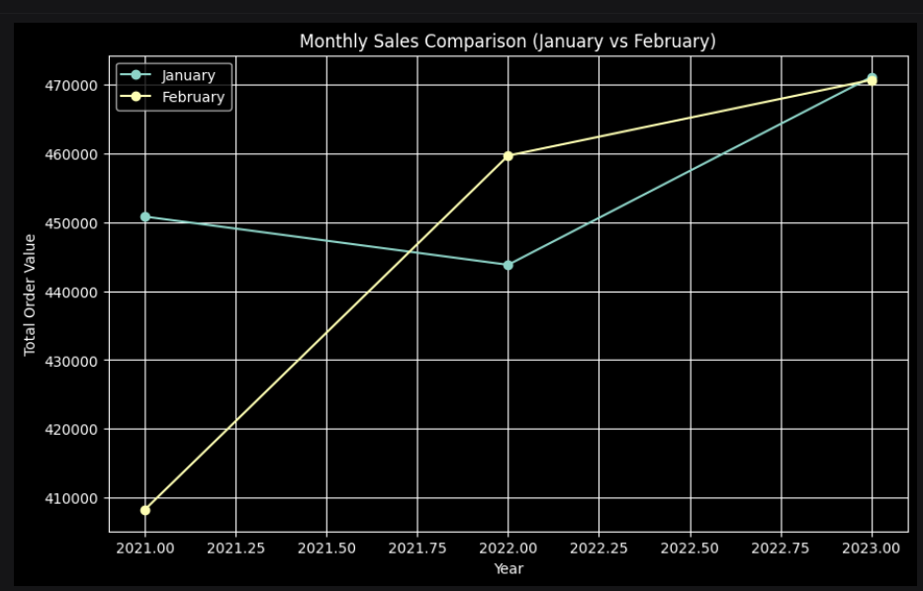

**4.2 Data visualization using Power BI**

**Introduction to Power BI**

**Interface Overview:**

* + Ribbon: Contains various tabs and commands for data connection, modelling, and visualization.
  + Report View: The main canvas where you create and arrange your visualizations.
  + Data View: Allows you to view and manage the data tables loaded into Power BI.
  + Model View: Helps you define relationships between different data tables.
  + Visualization Pane: Contains various visual elements that you can drag onto the report canvas.
  + Fields Pane: Lists all the data fields available for creating visualizations.
  + Filters Pane: Enables you to apply filters at the report, page, or visual level.
  + Connecting to Data Sources: Step-by-step instructions on how to connect Power BI to different data sources such as Excel, SQL Server, Azure, and online services.
  + Building Queries and Data Models: Demonstration of using Power Query Editor to transform and shape data, and creating relationships and calculations in the data model.

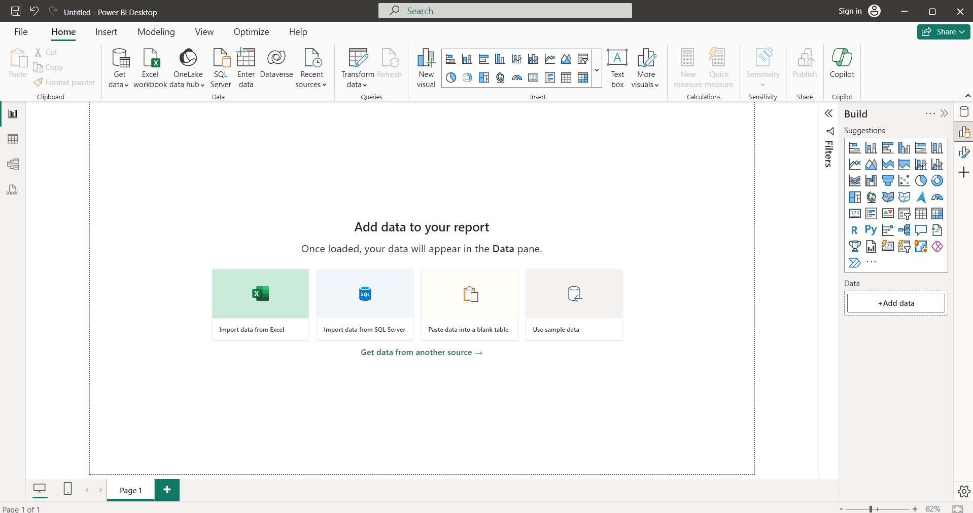

**Power BI Visualizations:**

1. **Card**

A Card visual displays a single value, such as a total, average, or other summary measure. It is ideal for highlighting key performance indicators (KPIs) or important metrics at a glance. Use cards to emphasize critical data points like total revenue, number of orders, or average sales price.

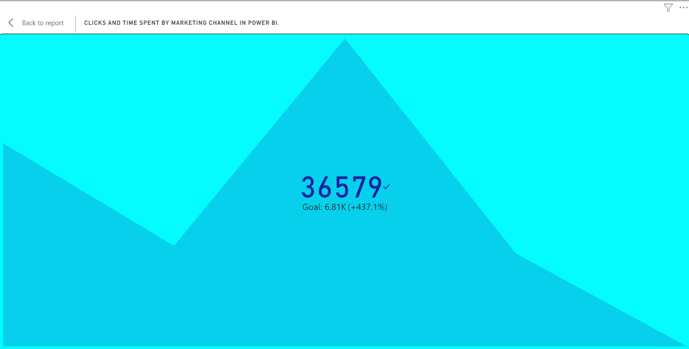

1. **Stacked Column Chart**

A Stacked Column Chart visualizes data with rectangular bars stacked on top of each other, representing different categories. It is useful for showing the cumulative contribution of each category over a period. For example, you can use it to display quarterly sales by product category, highlighting both individual and total sales.

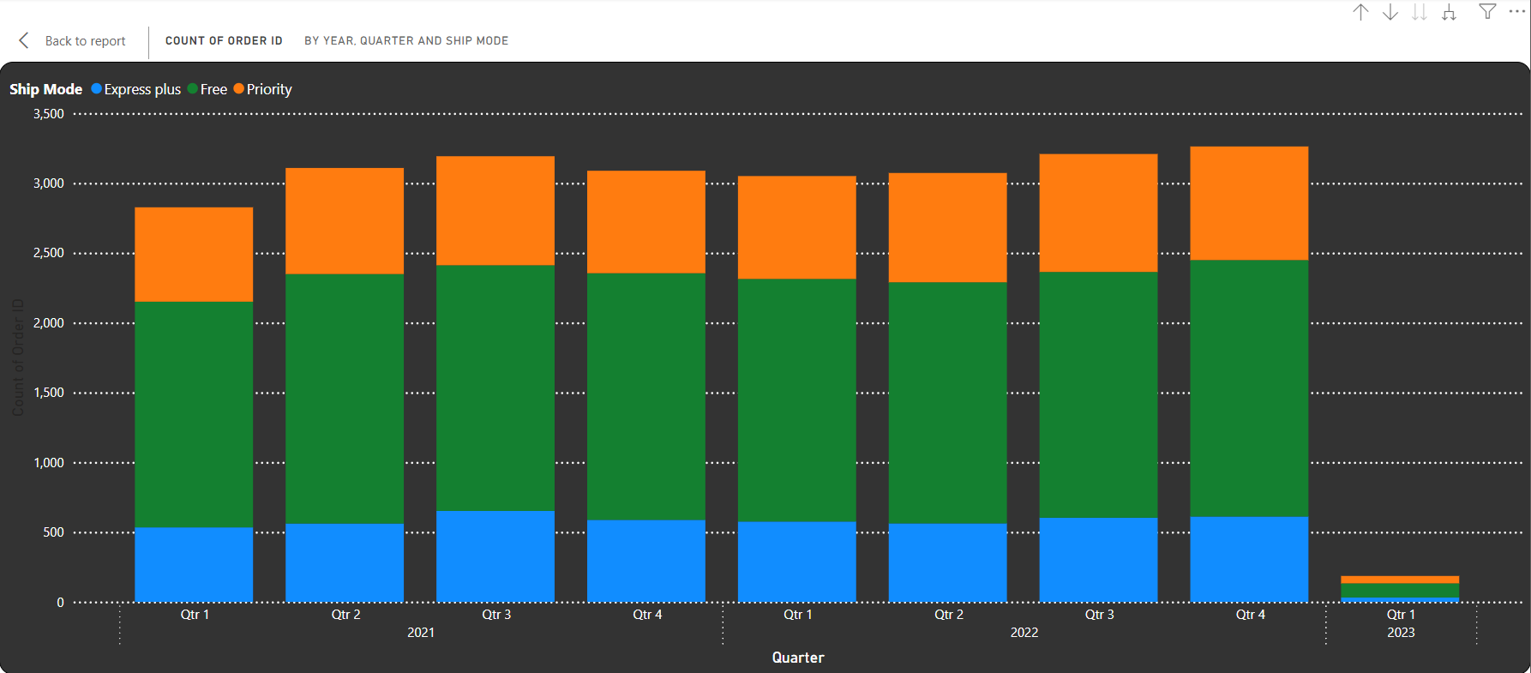

1. **Filled Map**

A Filled Map uses colour shading to represent data distribution across geographical regions. It is useful for showing regional performance metrics, such as sales volume or customer count by state or country. Filled maps provide a clear, visual way to identify trends and patterns based on location.

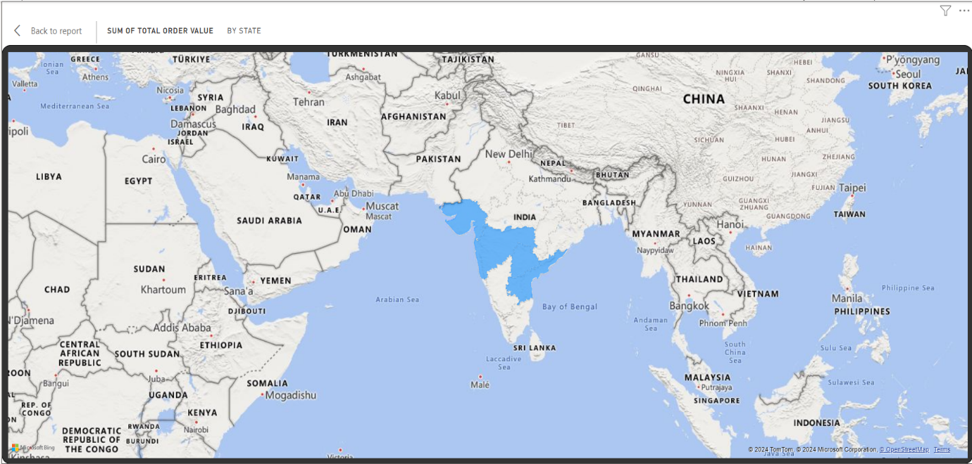

#### Line and Clustered Column Chart

#### Line and Clustered Column Chart combines a line graph and a clustered column chart in one visual. It is ideal for comparing two related metrics with different scales, such as sales volume (columns) and profit margin (line) over time, enabling a comprehensive analysis of trends and relationships.

1. **Donut Chart**

A Donut Chart is similar to a pie chart but with a central hole. It displays proportions of a whole, making it easier to read and interpret. Use donut charts to show percentage breakdowns of categories, such as market share by product or customer distribution by segment.

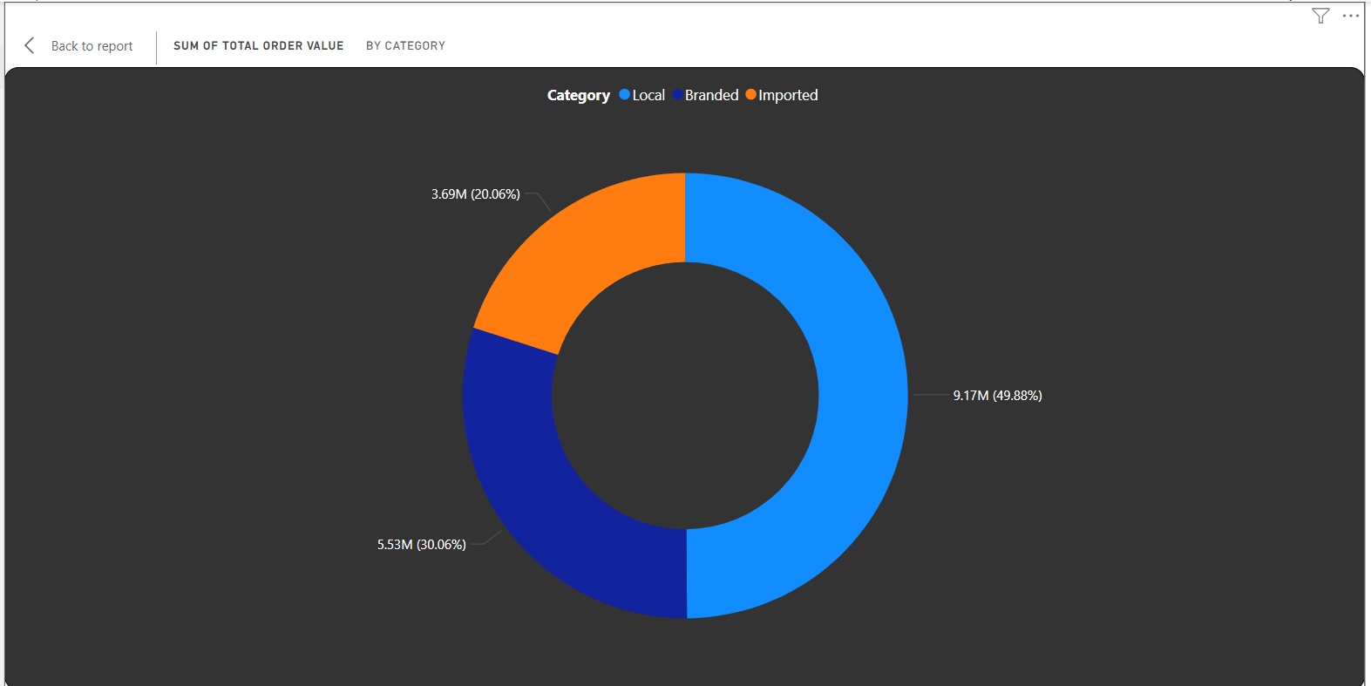

1. **Line Chart**

A Line Chart displays data points connected by straight lines, effectively showing trends over time. It is ideal for visualizing time-series data, such as monthly revenue or daily website traffic, helping to identify patterns, trends, and fluctuations over a specific period.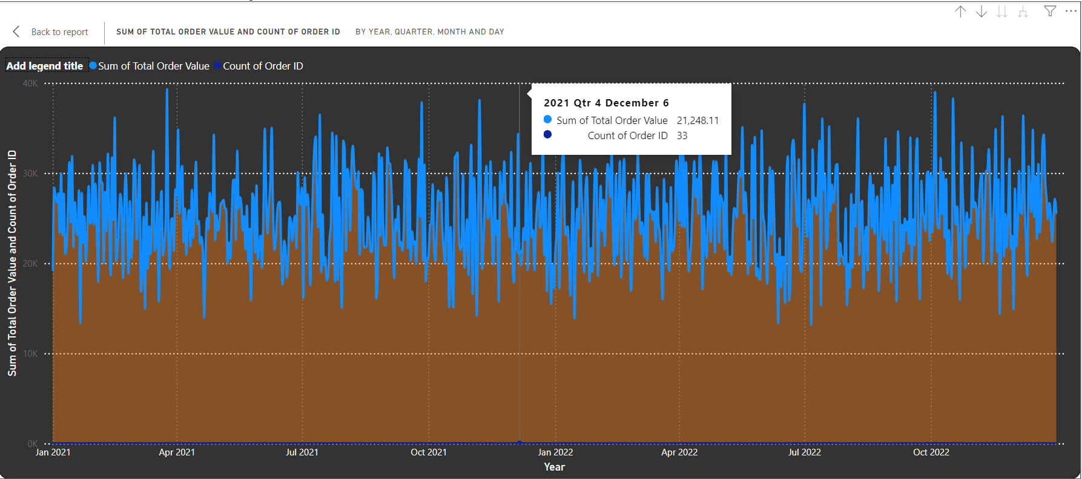

1. **Funnel Chart:**

A Funnel Chart visualizes stages in a linear process, highlighting drop-off points and conversion rates between stages. It is commonly used in sales and marketing to track the customer journey from lead generation to sales conversion, identifying areas for improvement.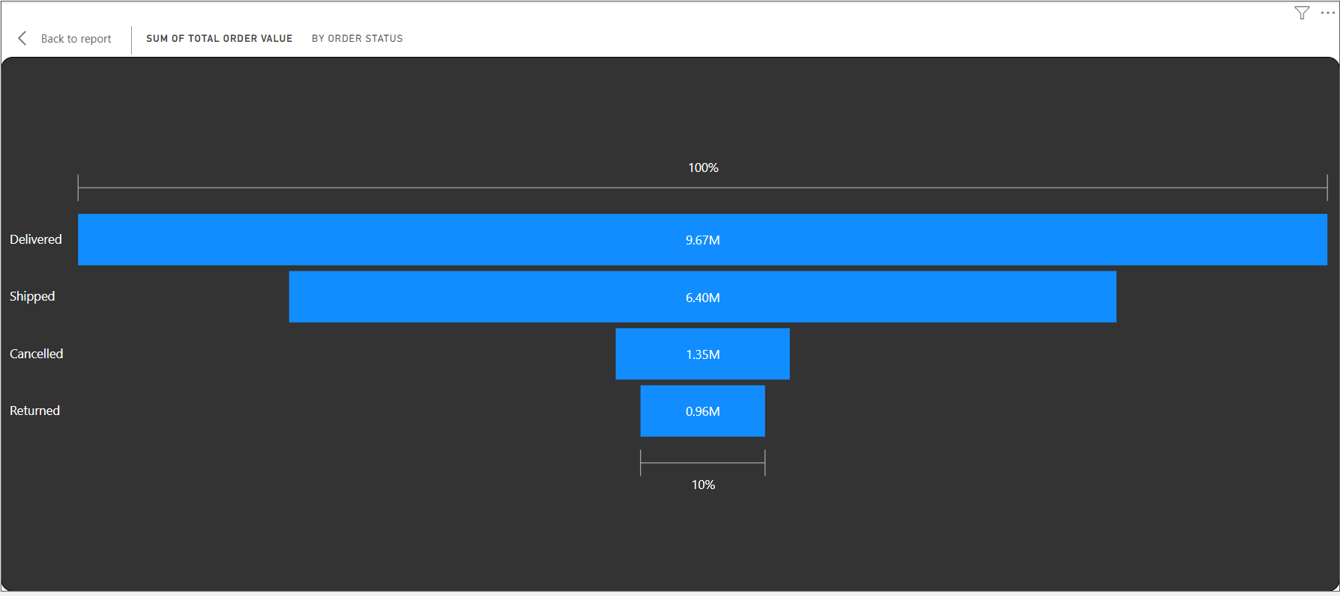

1. **Pie Chart**

A Pie Chart represents data as slices of a circle, showing proportions of a whole. It is useful for visualizing percentage distribution among categories, such as market share by product or budget allocation by department. Each slice’s size reflects its relative contribution to the total.

A pie chart showing the distribution of products by category. Notable products include Parle Nutr... (4.85%), Harpic Bat... (4.37%), and Wagh Bak... (4.33%).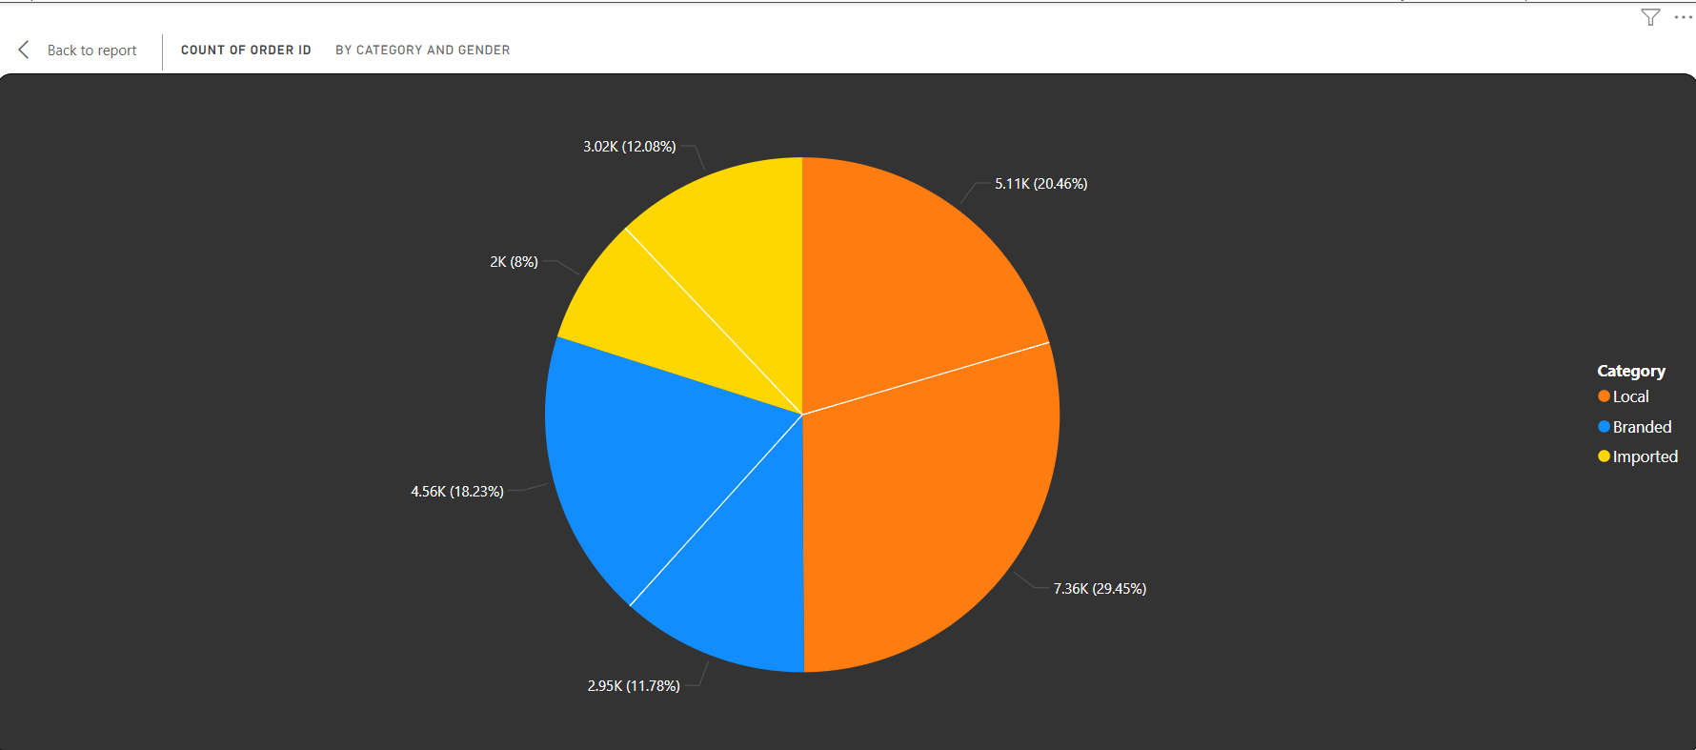

#### Stacked Area Chart

#### A Stacked Area Chart displays cumulative totals over time with shaded areas, representing different categories stacked on top of each other. It is useful for showing the composition of data over a period, such as sales by product category, and how each category contributes to the total.

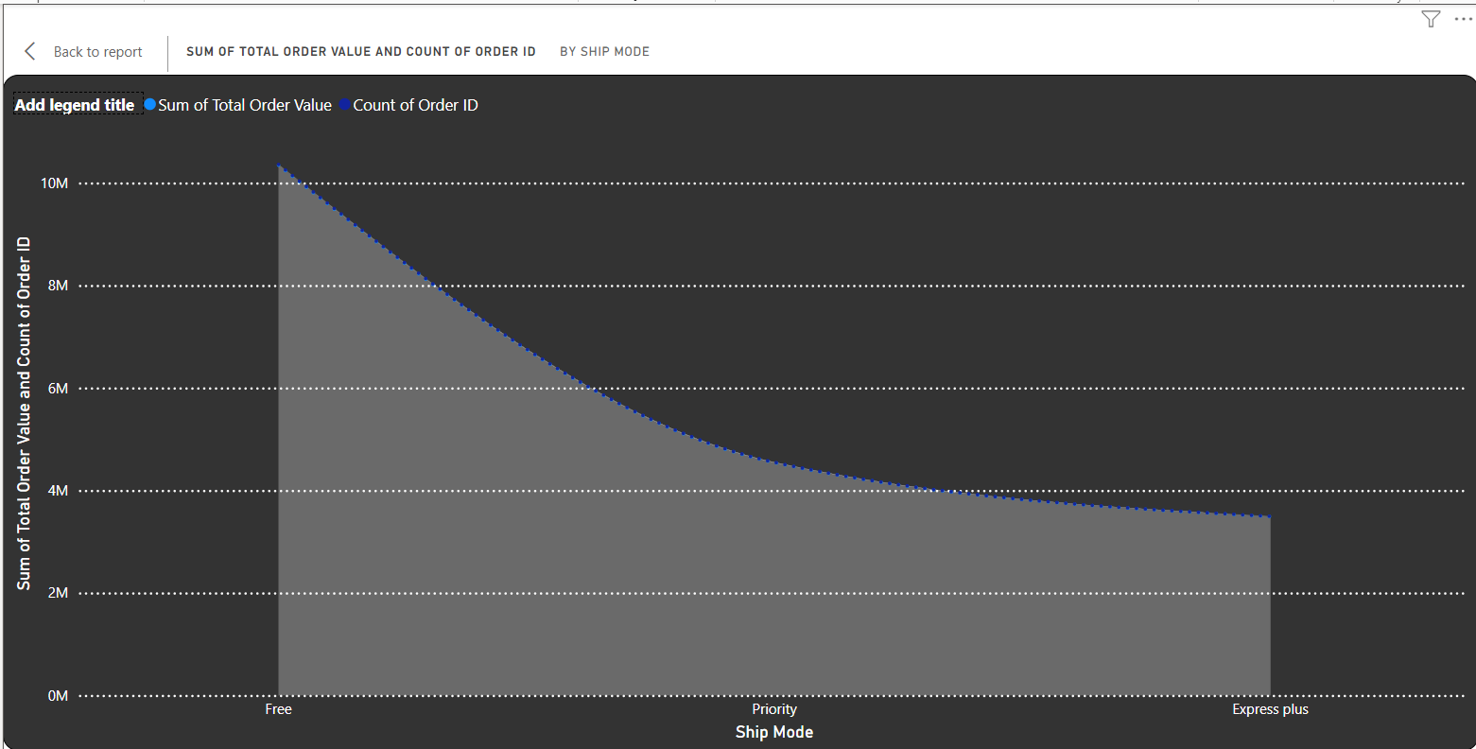

1. **Matrix**

A Matrix visual is a table with rows and columns that allows for hierarchical data grouping and drill-down capabilities. It is ideal for presenting detailed, multi-dimensional data, such as sales by region, product, and time period, enabling a comprehensive analysis.

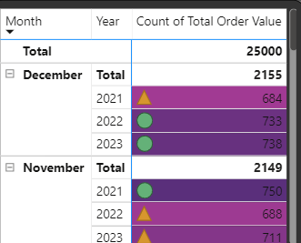

1. **100% Stacked Bar Chart**

A 100% Stacked Bar Chart displays the relative percentage contribution of categories to the whole, with each bar representing 100%. It is useful for comparing the proportional makeup of categories across different groups, such as market share by product in different regions.

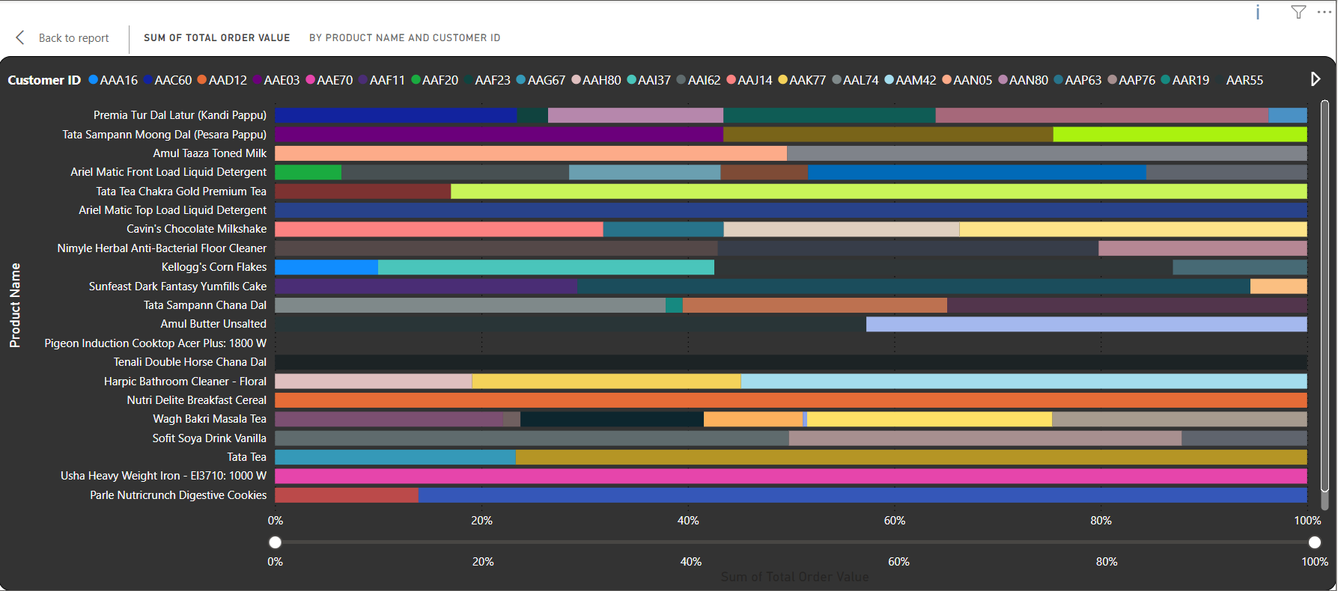

1. **Area Chart**

An Area Chart is similar to a line chart but with the area below the line filled in. It emphasizes the magnitude of change over time and is useful for showing cumulative data, such as revenue growth or stock prices, highlighting the overall trend and volume.



1. **Gauge Chart**

A Gauge Chart displays a single measure against a range of values, typically using a speedometer-like needle. It is useful for showing progress towards a goal, such as sales target achievement or customer satisfaction score, providing a quick visual status check.

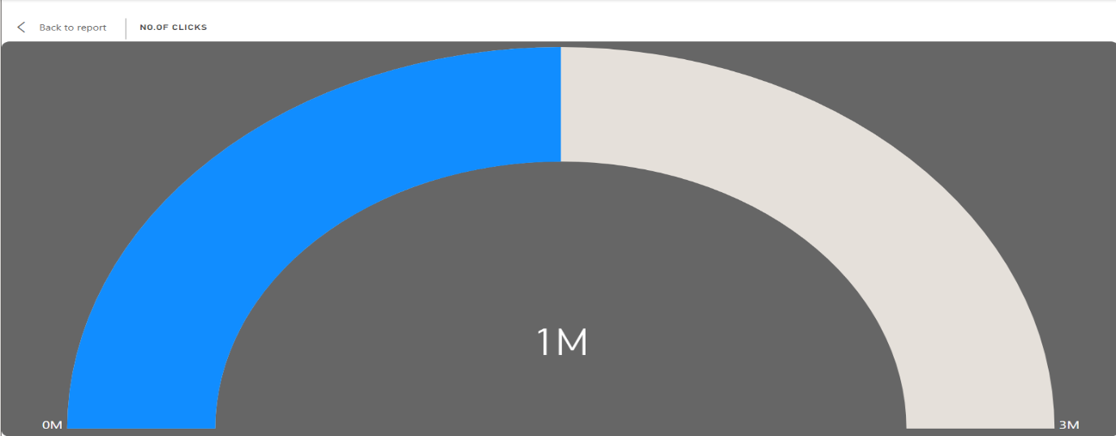

1. **Clustered Column Chart**

A Clustered Column Chart displays multiple series of data with vertical bars grouped side-by-side. It is useful for comparing multiple categories or groups, such as sales by product and region, showing how different series relate to each other within the same axis.

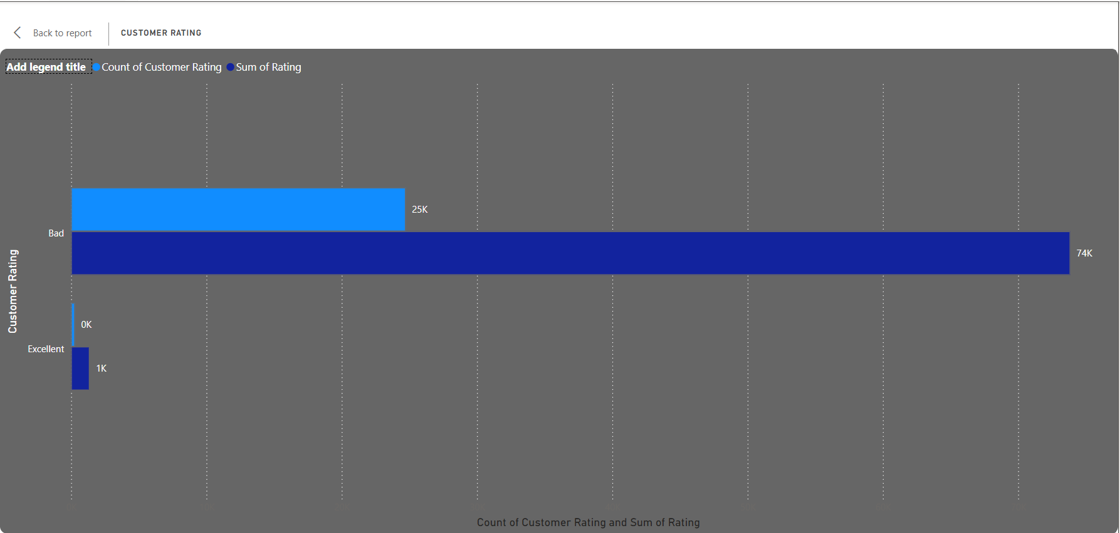

1. **Clustered Bar Chart**

A Clustered Bar Chart is similar to a clustered column chart but with horizontal bars. It is useful for comparing multiple categories side-by-side, such as revenue by department and region, highlighting differences and similarities across groups.

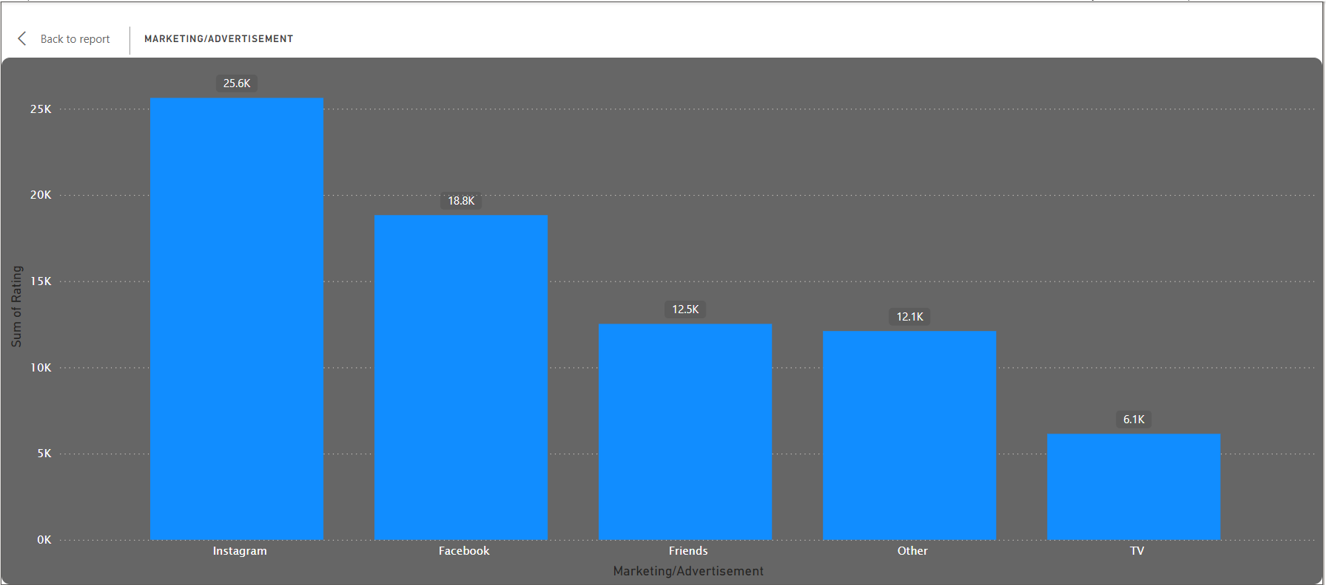

1. **Ribbon Chart**

A Ribbon Chart shows data over time with ribbons that flow and shift positions, representing changes in rank or value. It is useful for visualizing how categories compare to each other over a period, such as sales rankings of products or market position changes.

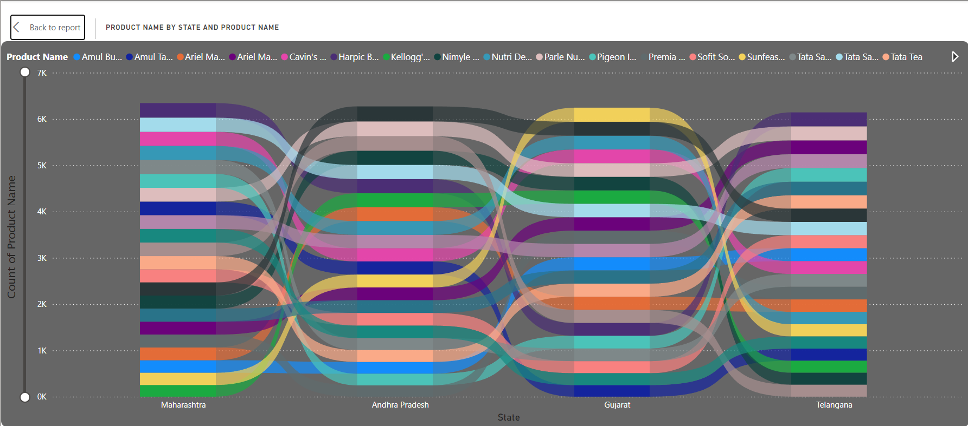

1. **Waterfall Chart**

A Waterfall Chart visualizes incremental changes to a cumulative total, showing how individual contributions add up to a final result. It is useful for financial analysis, such as tracking the impact of revenue and expenses on net profit, highlighting increases and decreases.

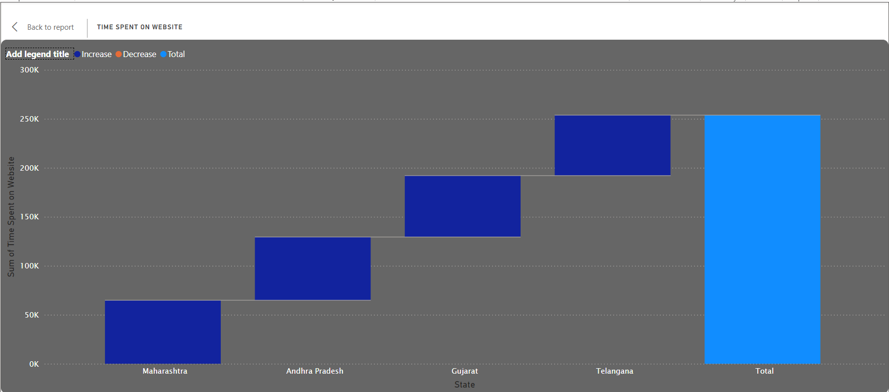

1. **KPI**

A KPI (Key Performance Indicator) visual displays progress towards a measurable goal. It typically shows the current value, target, and status, such as sales target achievement or customer satisfaction levels, providing a quick overview of performance metrics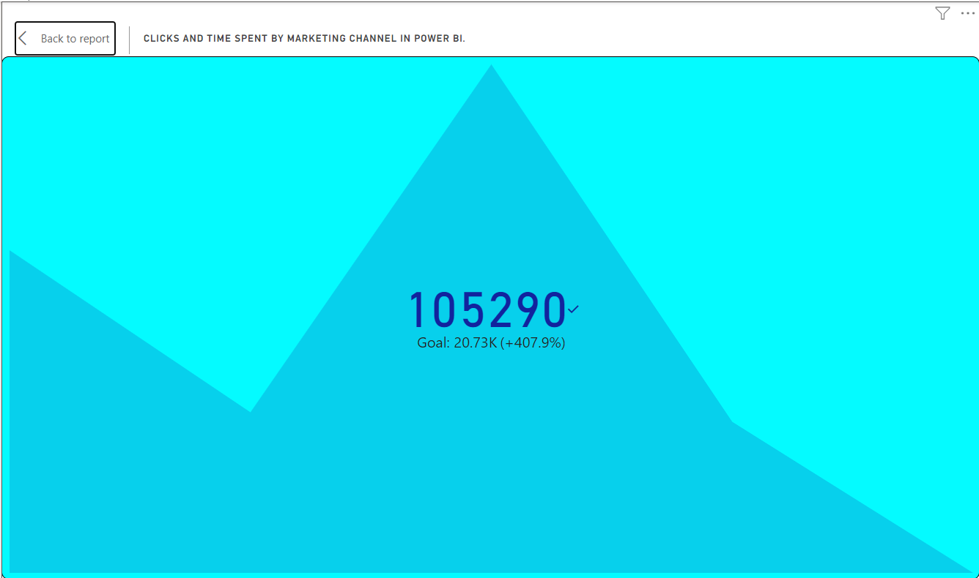.

1. **Scatter Plot**

A Scatter Plot displays individual data points on a Cartesian plane, showing the relationship between two variables. It is useful for identifying correlations, trends, and outliers, such as the relationship between advertising spend and sales revenue.

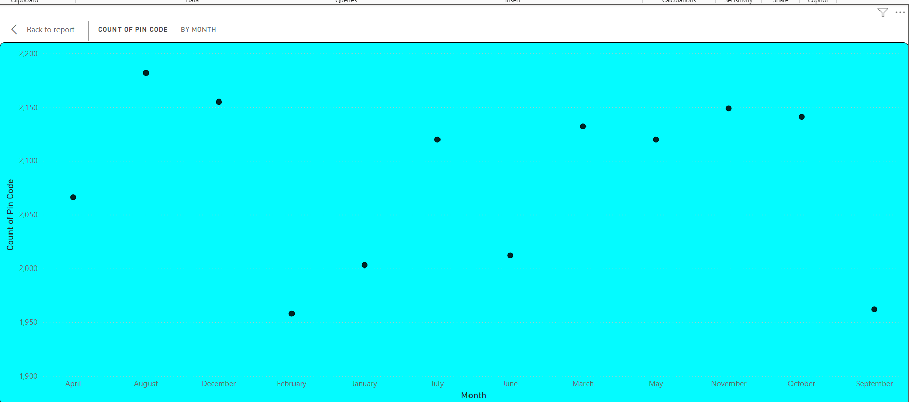

1. **Tree map**

A Tree map visualizes hierarchical data with nested rectangles, where the size and colour of each rectangle represent different dimensions. It is useful for displaying the proportion of categories within a whole, such as sales by product and sub-product, highlighting relative sizes

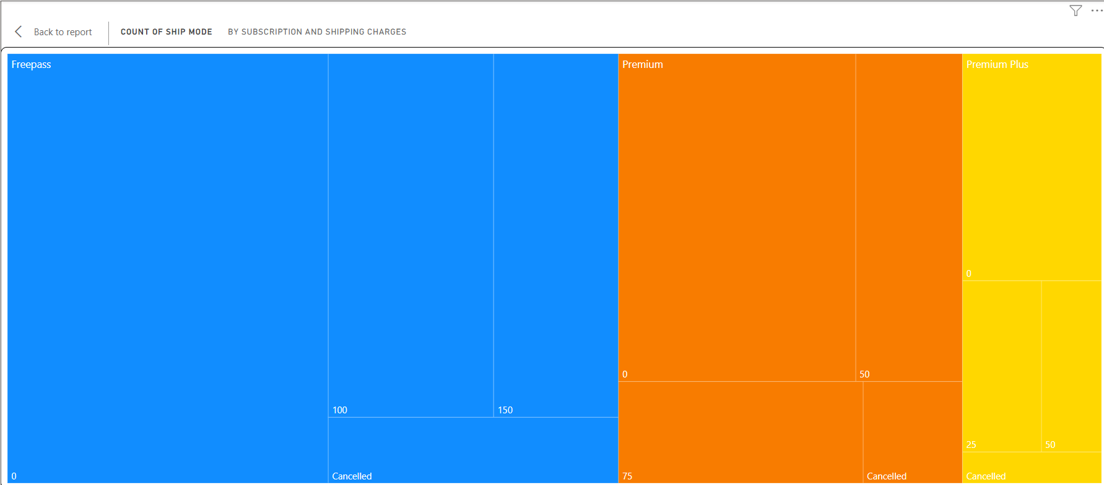

1. **Slicer**

A Slicer is an interactive filtering tool that allows users to segment and view specific portions of data. It is useful for dynamically filtering reports and visuals by criteria such as date, category, or region, providing a more focused and customized analysis.

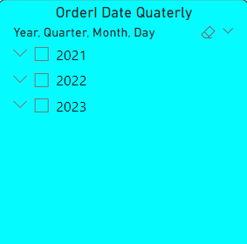

1. **Multi-row Card**

A Multi-row Card displays multiple data points or metrics in a compact, card-like format. It is useful for presenting key statistics or summaries, such as sales figures, customer counts, and profit margins, enabling quick and easy comparison of multiple values.

**Sales Performance Dashboard:**

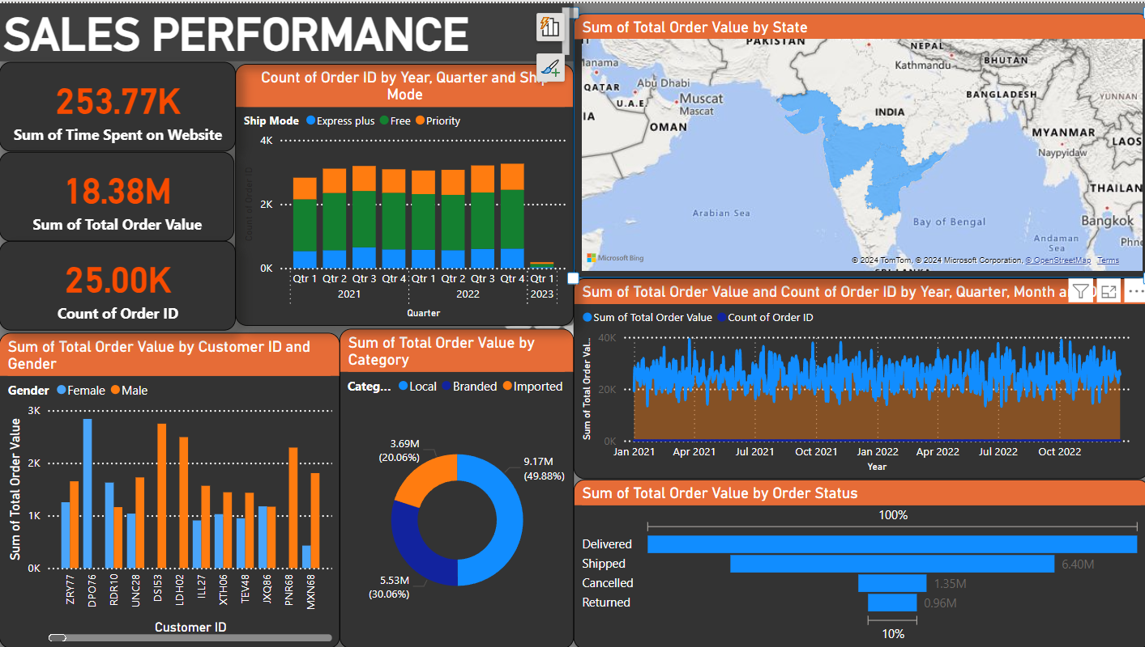

**Product Performance**

The "Product Performance" is a comprehensive and interactive visualization tool designed to provide a detailed overview of various performance metrics for a range of products. The dashboard is divided into several sections, each offering unique insights into key aspects of product performance and customer engagement.

**Key Metrics:**

* Total sum of sales: 16.95 million (17M).
* Category by Product Name: Donut chart.
* Order Count by Time and Ship Mode: Stacked column chart.
* Sum of Total Order Value based on States: Filled map chart.

**Detailed Visualizations**

The main section of the dashboard features various detailed visualizations that offer deeper insights into specific performance aspects:

* **Gender Distribution**
* A donut chart displaying the gender distribution of customers, with a majority being Male.
* **Marketing/Advertisement Channels**
* A bar chart illustrating the effectiveness of different marketing channels. Instagram leads with 26K interactions, followed by Facebook (19K) and Friends (13K).
* **Customer Rating**
* A bar chart showing the count and sum of customer ratings. There are 25K ratings classified as 'Bad' and 1K ratings classified as 'Excellent'.
* **Product Name by State and Product Name**
* A parallel coordinates chart detailing product performance across different states. The chart highlights popular products like Amul Butt... and Amul Taaz... across Maharashtra, Andhra Pradesh, Gujarat, and Telangana.
* **Time Spent on Website**
* A stacked bar chart representing the time spent on the website by state, with metrics for increase, decrease, and total time. The total time spent is highest, with notable time spent in Maharashtra and Telangana

**Interactive Elements**

Interactive elements such as filters for Branded, Imported, Local products, and Gender (Male, Female) allow users to customize their view and focus on specific data points of interest. This enhances the usability of the dashboard by enabling targeted analysis.

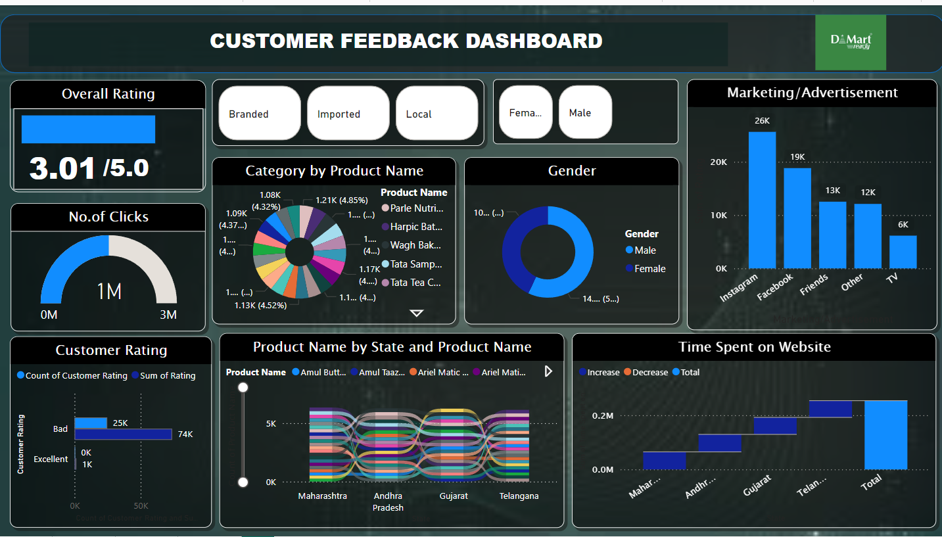

**Conclusion**

In conclusion, the "Product Performance Dashboard" offers a comprehensive and detailed view of product performance and customer engagement. It empowers stakeholders to make informed decisions by analysing critical metrics such as overall rating, number of clicks, customer demographics, and marketing effectiveness. Through its interactive and visually engaging design, the dashboard serves as a powerful tool for optimizing marketing strategies and improving product performance.

You can customize this summary with specific product names, metrics, and descriptions as needed. This structure ensures that you cover all key aspects and provide a detailed overview of your Power BI dashboard.

**Advanced Power BI Features**

DAX (Data Analysis Expressions) for Calculations

To create a comprehensive summary that includes an overview of DAX (Data Analysis Expressions) used in Power BI dashboard, we considered different DAX functions and calculations that are involved.

The dashboard utilized several DAX expressions to calculate and present key metrics.

1. **Overall Rating:**

Overall Rating = AVERAGE (Reviews [Rating])

This formula calculates the average rating from the Reviews table.

1. **Number of Clicks:**

Total Clicks = SUM (Clicks [Count])

This formula sums the click counts from the Clicks table.

1. **Customer Rating Count:**

Count of Ratings = COUNT (Ratings [CustomerID])

This formula counts the number of customer ratings.

1. **Marketing/Advertisement Interactions:**

Total Interactions = SUM (Marketing [Interactions])

This formula calculates the total interactions from different marketing channels.

1. **Time Spent on Website:**

Time Spent = SUM(WebsiteData[TimeSpent])

This formula sums the total time spent on the website.

**Challenges:**

**Performance Issues:**

* **Execution Speed:** Python scripts may run slower compared to native Power BI functions, especially with large datasets.
* **Resource Intensive:** Python can be resource-intensive, potentially affecting the performance of Power BI dashboards.

**Integration Complexity**:

* **Setup and Configuration:** Integrating Python with Power BI requires proper installation and configuration of Python on the local machine.
* **Library Management:** Ensuring that all necessary Python libraries are installed and compatible with Power BI can be cumbersome.

**Security Concerns:**

* **Execution of Scripts:** Running Python scripts can pose security risks, especially when dealing with sensitive or confidential data.
* **Access Permissions:** Proper permissions need to be managed to allow the execution of Python scripts within Power BI.

**Maintenance and Debugging:**

* **Script Maintenance:** Maintaining and updating Python scripts within Power BI can be more complex compared to using Power BI’s native functions.
* **Debugging:** Debugging Python scripts in Power BI is less straightforward, often requiring external tools or environments.

**Version Compatibility:**

* **Power BI Updates:** Updates to Power BI or Python can cause compatibility issues, requiring adjustments to existing scripts.
* **Library Updates:** Python libraries frequently update, which can lead to compatibility issues or require code changes.

**User Expertise:**

* **Learning Curve:** Users need to have knowledge of both Python programming and Power BI, which may require additional training.
* **Best Practices:** Ensuring that scripts follow best practices for performance and efficiency can be challenging, particularly for users who are new to Python.

**Environment Consistency:**

* **Local vs. Service:** Python scripts run in different environments when used in Power BI Desktop versus Power BI Service, potentially leading to inconsistencies.
* **Dependency Management:** Ensuring that all dependencies are consistently managed across different environments can be difficult.

**Key Future Trends in Data Analytics and Visualization**

1. AI and Machine Learning Integration

* + Predictive Analytics: Leveraging AI for forecasting future trends.
  + Automated Insights: AI-driven insights and narratives from data.

2. Real-Time Data Analytics

* Streaming Data: Instant insights from real-time data streams.
* Edge Analytics: Processing data at the edge for faster decision-making.

3. Advanced Visualization Techniques

* Immersive Analytics: Utilizing VR and AR for enhanced data visualization.
* 3D Visualizations: Improved spatial representation of complex data sets.

4. Self-Service and Augmented Analytics

* Self-Service Tools: Enabling non-technical users to perform data analysis.
* Augmented Discovery: AI recommendations to uncover hidden patterns.

5. Ethics and Data Governance

* Data Privacy: Protecting personal data and ensuring compliance.
* Ethical AI: Developing transparent and fair AI models.

**Chapter 5**

**Challenges:**

1. Integrating Python with PowerBI will be applied only with POWERBI service.
2. Due to large number of job titles, the entire data is not fitting into an entire graph. Because of

the large numbers of job title, we are unable to display the some of the insights accurately.

1. Extracting meaningful features (variables) from raw data, particularly job titles containing

unstructured text, is crucial for analysis but can be complex.

**Chapter 6**

**Glossaries:**

**1. Heat Map:**A graphical representation of data where individual values are represented by colors. It is used to visualize the distribution of customer ages by gender, with color intensity indicating the number of customers in each age group.

**2. 3D Scatter Plot:** A plot that visualizes data points in a three-dimensional space, representing customer age, time spent on the website, and number of clicks. It provides a comprehensive view of customer interaction metrics.

**3. Violin Plot:** A method of plotting numeric data that shows the density of the data at different values. It combines aspects of box plots and kernel density plots and is used to compare the distribution of total order values between genders.

**4. Facet Grid:** A grid of scatter plots that allows for detailed exploration of the relationship between different variables across multiple subsets of data. It helps in examining how variables interact within specific demographic and product categories.

**5. Ribbon (Power BI):** A component of the Power BI interface that contains various tabs and commands for data connection, modelling, and visualization.

**6. Data View (Power BI):** Part of the Power BI interface where users can view and manage the data tables loaded into the application.

**7. Model View (Power BI):** A feature in Power BI that helps define relationships between different data tables.

**8. Parallel Coordinates Chart:** A type of chart used to visualize multivariate data by plotting multiple variables as lines on parallel axes. It is used to detail product performance across different states in the Product Performance Dashboard.

**9.Holistic Retail Management:** This involves the integration of various aspects of retail operations such as supply chain coordination, inventory control, and customer service to ensure seamless operations and a consistent customer experience.

**10. Customer Data Analysis:** Analysing customer data to gain insights into customer behaviour, preferences, and trends. This analysis helps in personalized marketing, improving customer service, and developing products that meet customer needs.

**11.Supply Chain Coordination:** The process of managing and synchronizing the flow of goods, information, and finances as they move from supplier to manufacturer to wholesaler to retailer to consumer. Effective supply chain coordination enhances efficiency and reduces costs.

**12.Inventory Control:** Techniques and strategies used to manage inventory levels, track inventory movements, and ensure the right amount of stock is available at the right time. This helps in minimizing costs and meeting customer demand efficiently.

**13.Data Analytics:** The process of examining datasets to draw conclusions using specialized systems and software. It includes techniques ranging from simple statistical analysis to complex data mining and predictive analytics.

**14. Data Visualization:** The graphical representation of information and data using visual elements like charts, graphs, and maps. It makes trends, outliers, and patterns in data more accessible and understandable.

**15.Customer Lifetime Value (CLV) Analysis:**Analyzing historical purchase data and customer interactions to estimate the future value each customer brings to the company. It helps in identifying high-value customers and optimizing retention strategies.

**16.Sentiment Analysis:** Analyzing customer feedback, reviews, and social media interactions to gain insights into customer satisfaction and brand perception. It helps in identifying areas for improvement and enhancing the customer experience.

**17.Descriptive Statistics:** The analysis of data that helps describe, show, or summarize data in a meaningful way such as calculating the mean, median, standard deviation, minimum, maximum, and quartiles of numerical attributes.

**18. DAX (Data Analysis Expressions):** A collection of functions, operators, and constants used in Power BI to perform advanced calculations on data in the model. It is used for creating custom metrics and aggregations in Power BI dashboards.

**Chapter 7**

**CONCLUSION:**

The "Product Performance Dashboard" provides a robust and detailed analysis of product performance and customer engagement. By leveraging advanced data visualization techniques such as heat maps, 3D scatters plots, and violin plots, it offers stakeholders critical insights into customer behaviour and product metrics. Key performance 0078indicators like overall rating, number of clicks, customer demographics, and marketing effectiveness are clearly illustrated, enabling informed decision-making. Interactive elements, including filters for branded, imported, and local products, as well as gender-specific analysis, enhance the usability of the dashboard, making it a powerful tool for targeted analysis and strategy optimization. The integration of Power BI and Python significantly contributes to data processing and visualization, supporting the depth and accuracy of the analysis. The dashboard reveals a comprehensive view of customer interactions with products, highlighting significant engagement through various marketing channels, particularly Instagram and Facebook. Additionally, a detailed regional analysis showcases the performance of key products across different areas, identifying trends and opportunities for targeted marketing efforts. Overall, the dashboard empowers stakeholders to optimize marketing strategies, improve product performance, and drive sustainable growth by providing a visually engaging and interactive platform for analyzing complex data sets.

**Chapter 9**

**References:**

<https://www.python.org/>

[https://www.microsoft.com/en-us/power-platform/products/power-bi#tabs-pill-bar-ocb9d418_tab1](https://www.microsoft.com/en-us/power-platform/products/power-bi%23tabs-pill-bar-ocb9d418_tab1)

<https://www.kaggle.com/datasets/praneethkumar007/dmart-ready-online-store>

[pandas - Python Data Analysis Library](https://pandas.pydata.org/)

[GeoPandas 0.14.4 — GeoPandas 0.14.4+0.g60c9773.dirty documentation](https://geopandas.org/en/stable/)

[Top 50 matplotlib Visualizations - The Master Plots (w/ Full Python ...](https://www.machinelearningplus.com/plots/top-50-matplotlib-visualizations-the-master-plots-python/)

[Guy in a Cube - YouTube](https://www.youtube.com/guyinacube)

[How to Choose the Right Data Visualization | Atlassian](https://www.atlassian.com/data/charts/how-to-choose-data-visualization)

**APPENDIX 1**

For this project we have used the following system configuration:

* Windows 11
* POWERBI DESKTOP
* Matplotlib: 3.6.3
* Plotly (io):5.3.0
* python 3.12.1
* sacremoses 0.1.1
* scikit-learn 1.4.2
* scipy 1.12.0
* seaborn 0.13.2
* numpy 1.26.4
* geopandas 0.14.4
* plotly 5.22.0
* pandas 2.2.2
* pip 23.3.2
* palettable 3.3.3
* power Bi 2.129.1229.